

**AMERICAN INTERNATIONAL UNIVERSITY–BANGLADESH (AIUB)**

**Department of the Faculty of Science and Technology**

**Summer 2024-2025**

**Project Report On**

**Laundry Service Management System**

**Supervised By**

**JUENA AHMED NOSHIN**

|  |  |  |
| --- | --- | --- |
| **Name** | **ID** | **Contribution** |
| **Tanvir Arabi** | **22-47857-2** | **Design user interface, Normalization, Query implementation, and Data insertion (34%)** |
| **Bushra Kaiser** | **22-47679-2** | **Scenario Description, ER Diagram, Schema Diagram, Data Insertion, and Query Implementation – (33%)** |
| **MD. Anas Khan** | **20-43091-1** | **Design user interface, Normalization, Query implementation, and Data insertion (33%)** |
| **MD Ridoyuzzaman** | **22-47287-1** | **0%** |

**ADVANCED DATABASE MANAGEMENT SYSTEM**

**Section: B**

**Group No: 04**

**Contents:**

|  |  |
| --- | --- |
| **Content Name** | **Page No** |
| Introduction | 3 |
| Project Proposal | 3-4 |
| User Interface Planning | 4-9 |
| Scenario Description | 9-10 |
| ER Diagram | 10 |
| Normalization | 11-12 |
| Schema Diagram | 13 |
| Table Creation | 13-17 |
| Data Insertion | 18-22 |
| Basic PL/SQL | 22-27 |
| Advance PL/SQL | 28-37 |
| Conclusion | 37 |

***Title: Laundry Service Management System.***

**Introduction:**

The goal of our project is to simplify and organize the management of a laundry operation. It facilitates the laundry service's management of employees, customers, and services provided. Regular customers will obtain a unique membership card with discounted prices and they seek laundry delivery and pickup straight from their homes. Lastly, the system manages utility bills, which are paid for by clients. It is a tool that simplifies the whole laundry service process for the company and its customers and makes life easier.

**Project Proposal :**

**(i)Problem Background:**The laundry marketplace has a lot of problems, particularly for small and medium-sized companies. These problems impact both the service providers and their clients. Managing staff, client orders, and invoicing by hand and in the old-fashioned way typically leads to errors, inefficiencies, and bad customer service. In today's fast-paced world, when clients want speedy and dependable service, this dilemma is much worse. For students in higher education and those who are employed, doing laundry may be a pain since they are typically busy and don't have a lot of time. They could have trouble making time to go to the laundromat or do laundry at home. Also, laundry services typically don't meet their demands, including providing home pickups or flexible hours, which makes it tougher for people to trust these services.

**(ii)Objective:**

The Laundry Service Management System solves these problems by automating important operations like managing employees, helping customers, and invoicing, which makes the experience better for both the business and the client. The system has features that save time for students in higher education and those who are employed, such as the ability to request home service, get membership perks, and pay bills and make payments easily.

**(iii) Benefits:**

The Laundry Service Management System increases productivity by automating processes, including processing payments, coordinating staff, and responding to client demands. It offers a practical solution with home pickup and delivery services, saving valuable time for jobholders and bachelor students. Direct utility bill payment, membership card discounts, and laundry status monitoring are all available to customers. Along with increasing staff productivity and ensuring timely and adaptable services, the technology also helps reduce operating expenses. Technology makes operations easier and gives clients a more convenient experience with its consolidated data, real-time tracking, and scalability.

**User Interface planning :**

**(Registration & Login)**

|  |  |
| --- | --- |
|  |  |
|  |  |
|  |  |

**(Available Customer Status Dashboard)**

|  |  |
| --- | --- |
|  |  |

|  |
| --- |
|  |

|  |  |
| --- | --- |
|  |  |
|  |  |

**Dashboard:**

|  |  |
| --- | --- |
|  |  |
|  |  |

**Schedule & Payment option**

|  |  |
| --- | --- |
|  |  |
|  |  |

**Scenario Description :**

In the Laundry Service Management System, a Laundry Service can have many employees, but each employee works for only one Laundry Service. Each Employee is identified by a unique EmployeeID and has attributes such as name, age, address, date of birth, and phone number. A Laundry Service is identified by a unique LaundryServiceID and is characterized by its address and contact phone number. A Laundry Service may be owned by exactly one owner, and similarly, each Owner rents exactly one Laundry Service. The Owner is identified by their name, address, email, and phone number. A Laundry Service may serve many Customers, where each Customer is given a unique customer ID along with details like name, address, email, and phone number. A Customer can have multiple email addresses and phone numbers for communication purposes. For regular Customers, a special membership card will be provided. This card will include a MemberCardID, member name, discount, and phone number. The customer is responsible for paying a Utility Bill, which has a unique UtilityBillID, along with the payment type and the amount due for the services rendered. A Laundry Service may offer Home Services, where an Employee picks up laundry from the Customer's Home Address and delivers it back after cleaning. Each Home Service is identified by a unique HomeServiceID. Home Service Records store the details such as the HomeServiceID, pickup date, delivery date, employee assigned to the service, and the Customer's Home Address. Each Home Service can have one or more Employees assigned to it, depending on the nature of the service. Employees are responsible for picking up and delivering laundry. Customers can request Home Service through the system, and it will be tracked for payment and service completion.

**ER Diagram**

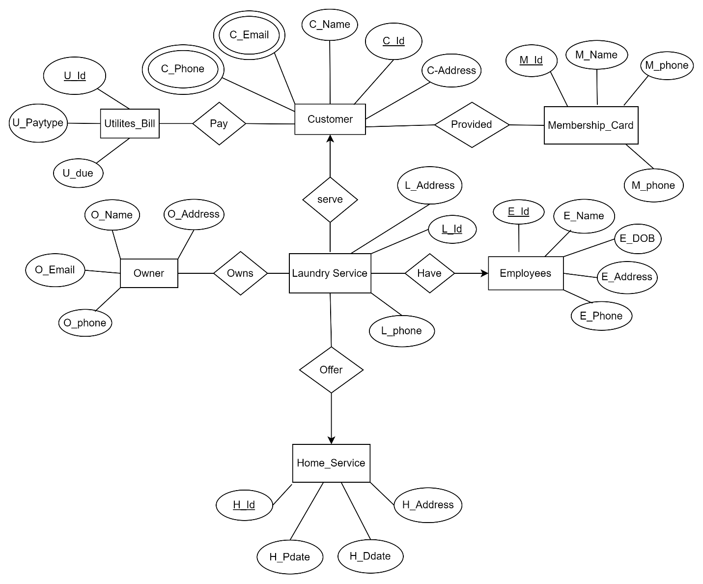

**Normalization:**

**1NF (First Normal Form)**

A table is in 1NF if it meets these criteria:

* Each column contains a single, atomic value.
* There are no repeating groups of columns.

The ER diagram suggests the following initial tables. Primary keys are bolded.

* Customer (C_Id, C_Name, C_Address, C_Email, C_Phone)
* Utilities_Bill (U_Id, U_paytype, U_due, Pay)
* Membership_Card (M_Id, M_Name, M_phone, Provided)
* Owner (O_Id, O_Name, O_Address, O_Email, O_phone, Owns)
* Employees (E_Id, E_Name, E_DOB, E_Address, E_phone, Have)
* Laundry_Service (L_Id, L_Address, L_phone, Serve)
* Home_Service (H_Id, H_Pdate, H_Ddate, H_Address, Offer)

**2NF (Second Normal Form)**

A table is in 2NF if it is in 1NF and all non-key attributes are fully dependent on the primary key. This is only relevant for tables with a composite primary key.

Based on the ER diagram, we need to create linking tables to represent the relationships and ensure full dependency.

* Customer (C_Id, C_Name, C_Address, C_Email, C_Phone) - C_Id is the primary key. No changes needed.
* Utilities Bill (U_Id, U_paytype, U_due) - We remove Pay as it's a relationship. U_Id is the primary key.
* Membership Card (M_Id, M_Name, M_phone) - We remove Provided as it's a relationship. M_Id is the primary key.
* Owner (O_Id, O_Name, O_Address, O_Email, O_phone) - We remove Owns as it's a relationship. O_Id is the primary key.
* Employees (E_Id, E_Name, E_DOB, E_Address, E_phone) - We remove Have as it's a relationship. E_Id is the primary key.
* Laundry Service (L_Id, L_Address, L_phone) - We remove Serve as it's a relationship. L_Id is the primary key.
* Home Service (H_Id, H_Pdate, H_Ddate, H_Address) - We remove Offer as it's a relationship. H_Id is the primary key.

**Now, we create the new linking tables for the relationships:**

* Customer_Pays_Bill (C_Id, U_Id) - Composite primary key (C_Id, U_Id). Represents the Pay relationship.
* Customer_Has_Membership (C_Id, M_Id) - Composite primary key (C_Id, M_Id). Represents the Provided relationship.
* Owner_Owns_Laundry (O_Id, L_Id) - Composite primary key (O_Id, L_Id). Represents the Owns relationship.
* Laundry_Serves_Customer (L_Id, C_Id) - Composite primary key (L_Id, C_Id). Represents the Serve relationship.
* Employees_Have_Laundry (E_Id, L_Id) - Composite primary key (E_Id, L_Id). Represents the Have relationship.
* Laundry_Offers_Home_Service (L_Id, H_Id) - Composite primary key (L_Id, H_Id). Represents the Offer relationship.

**All non-key attributes are now fully dependent on the primary key, satisfying 2NF.**

**3NF (Third Normal Form)**

A table is in 3NF if it is in 2NF and has no transitive dependencies. A transitive dependency is when a non-key attribute depends on another non-key attribute.

Reviewing the tables, there don't appear to be any transitive dependencies. All attributes directly relate to their respective primary keys. For instance, in the Customer table, C_Name, C_Address, C_Email, and C_Phone all directly describe a C_Id. The same is true for all other tables. Therefore, the tables from 2NF are already in 3NF.

**Summary of Table Names After Normalization:**

* **Customer:** Customer
* **Membership_Card:** Membership_Card
* **Owner:** Owner
* **Employees:** Employees
* **Laundry_Service:** Laundry_Service
* **Home_Service:** Home_Service
* **Utilites_Bill:** Utilites_Bill
* **Customer_Pays_Bill:** Cust_Pays_Bill
* **Laundry_Service_Offers_Home_Service:** LS_Offers_HS

**Schema Diagram:**

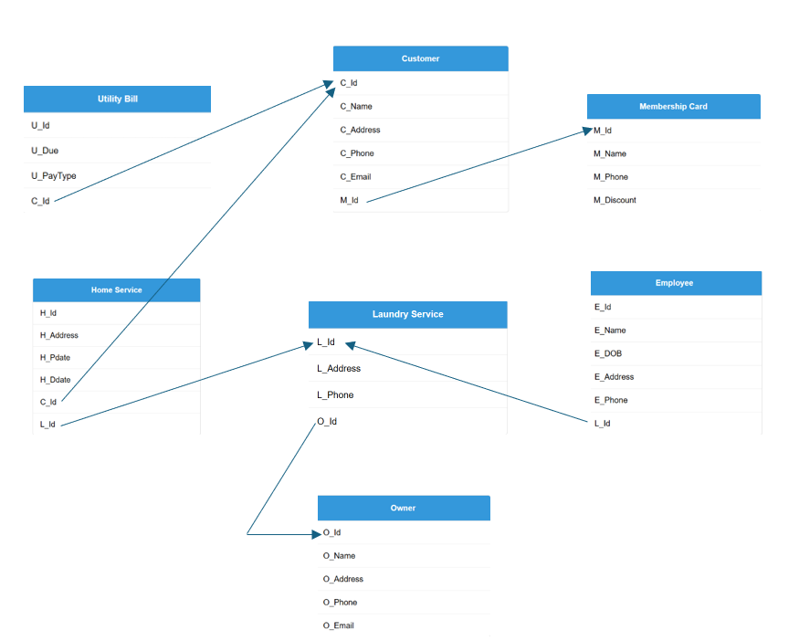

**Table creation using SQL:**

**1.Customer:**

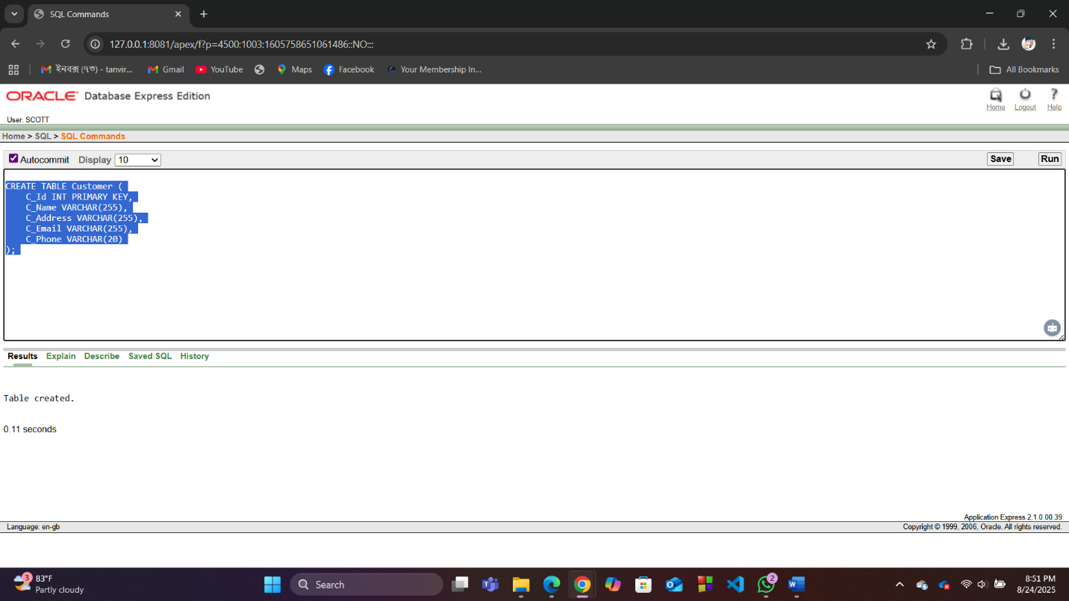

**2.Membership_card**

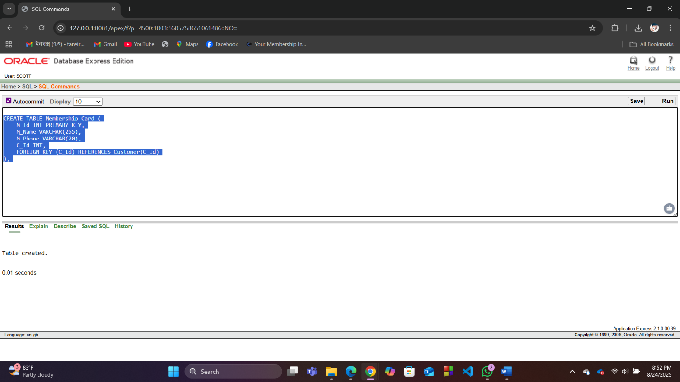

**3.Owner**

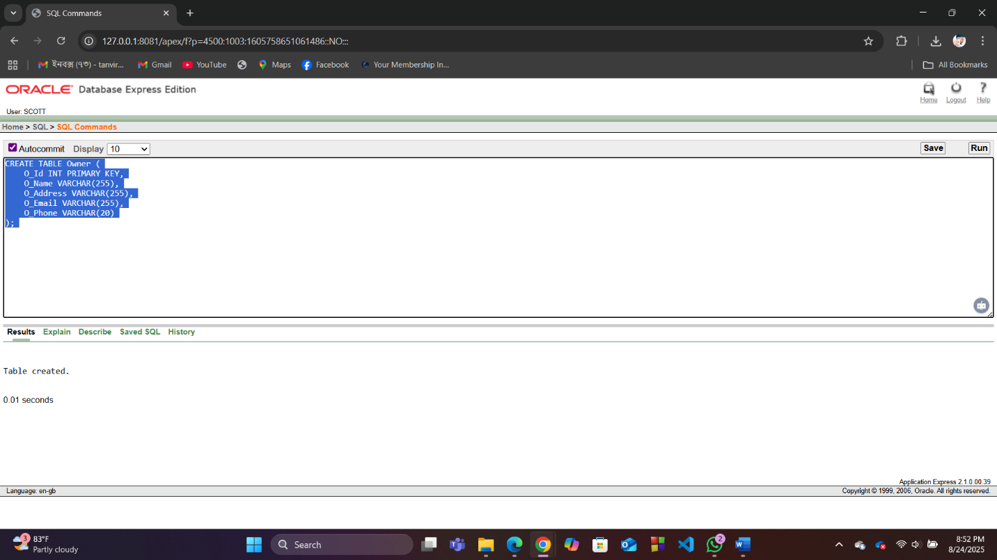

**4.Employees**

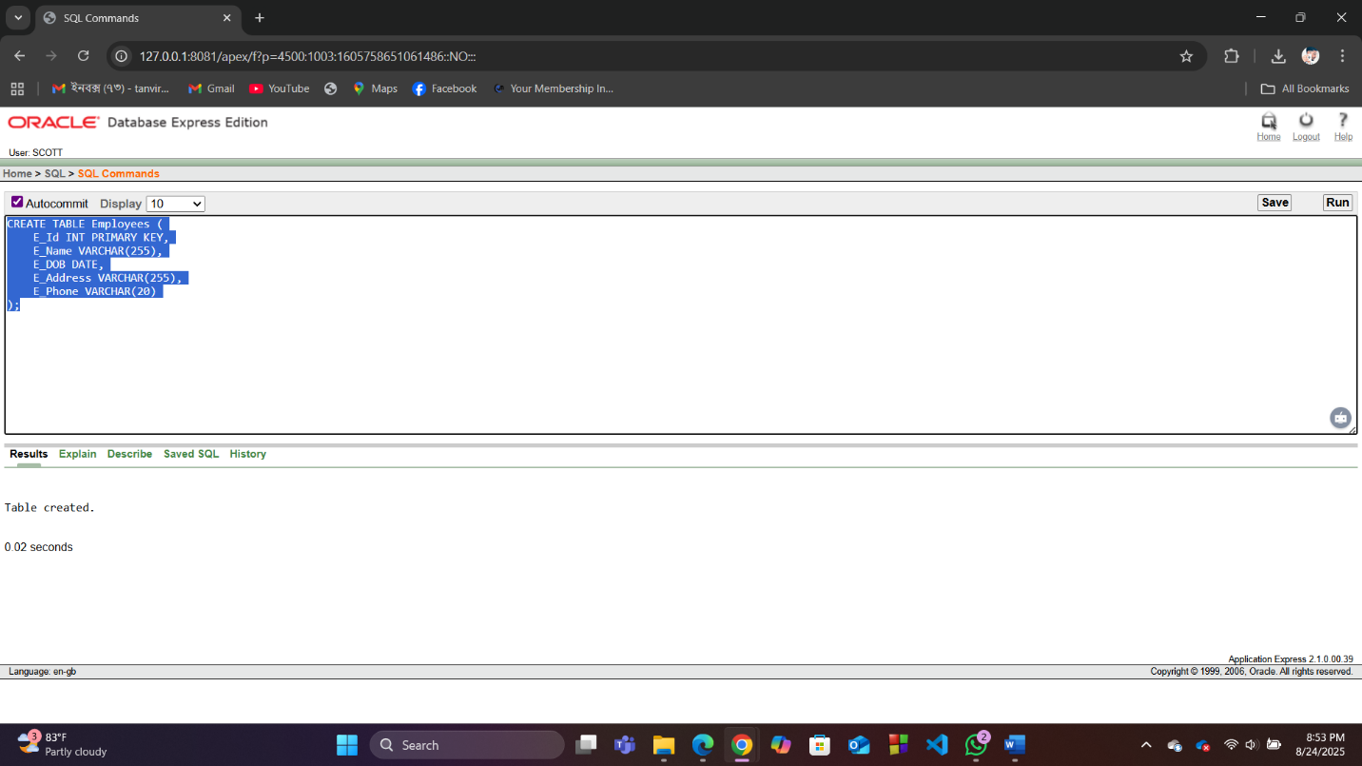

**5.Laundry_Service**

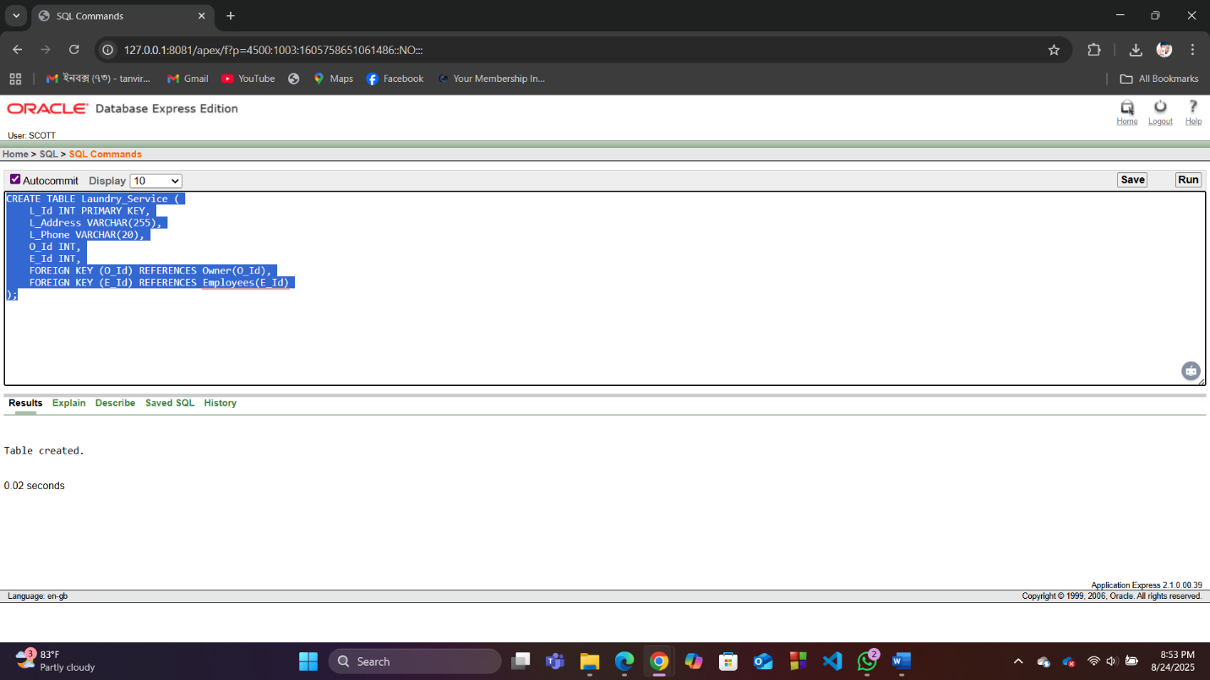

**6.Home_Service**

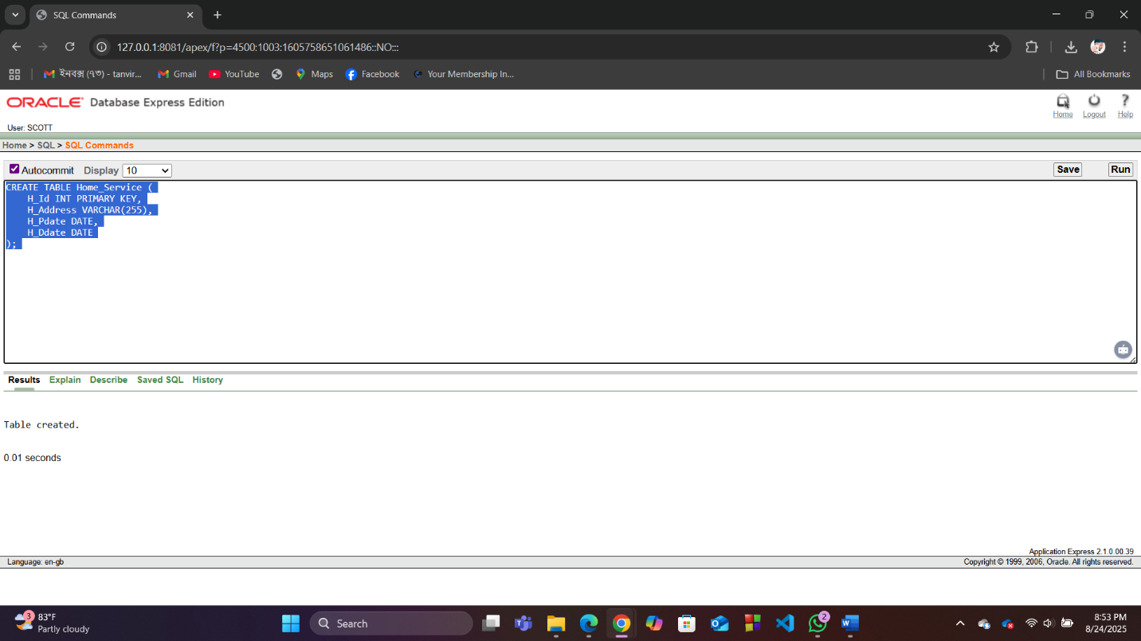

**7.Utilities_Bill**

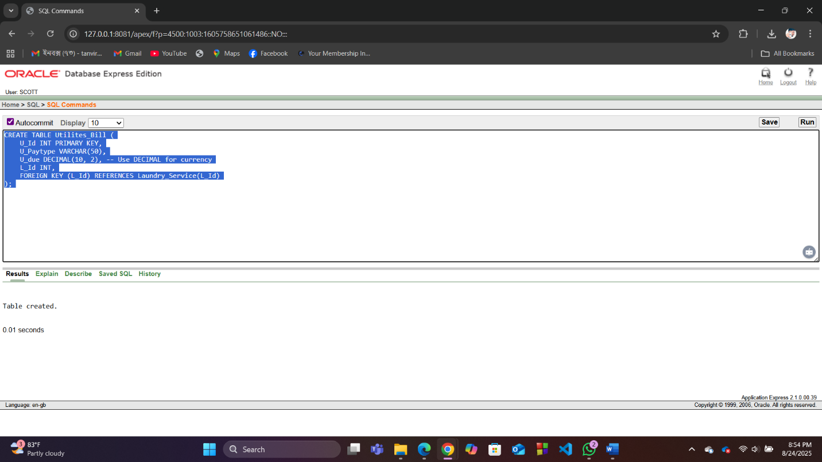

**8.Cust_Pays_Bill**

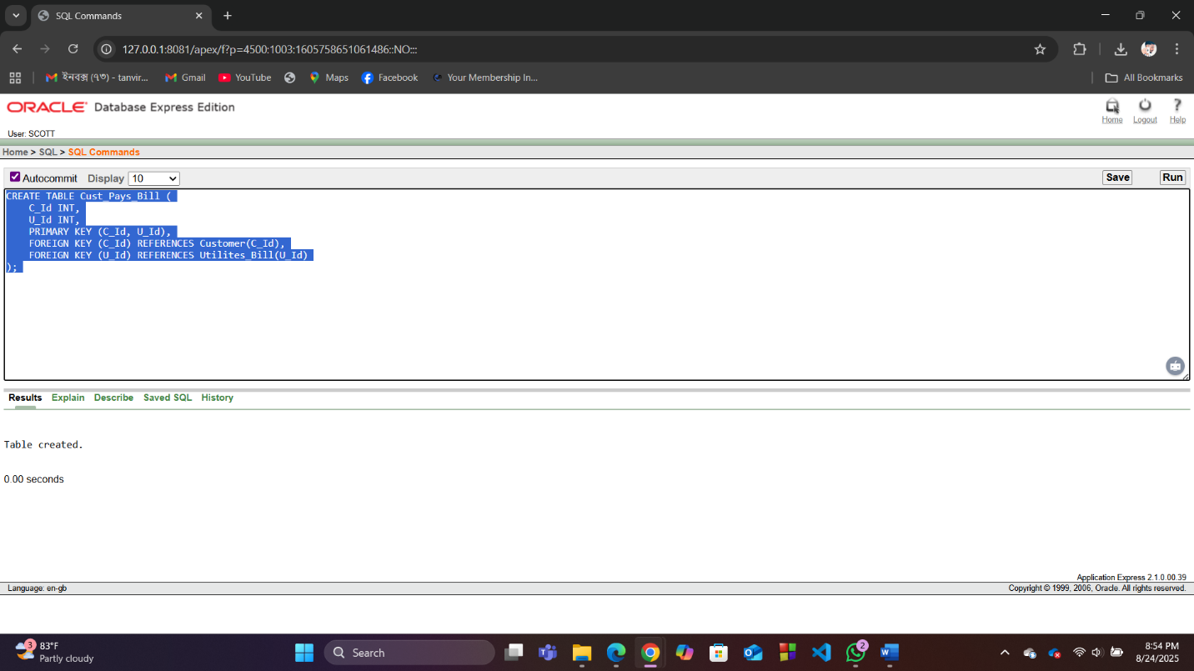

**9.Offers_Hs**

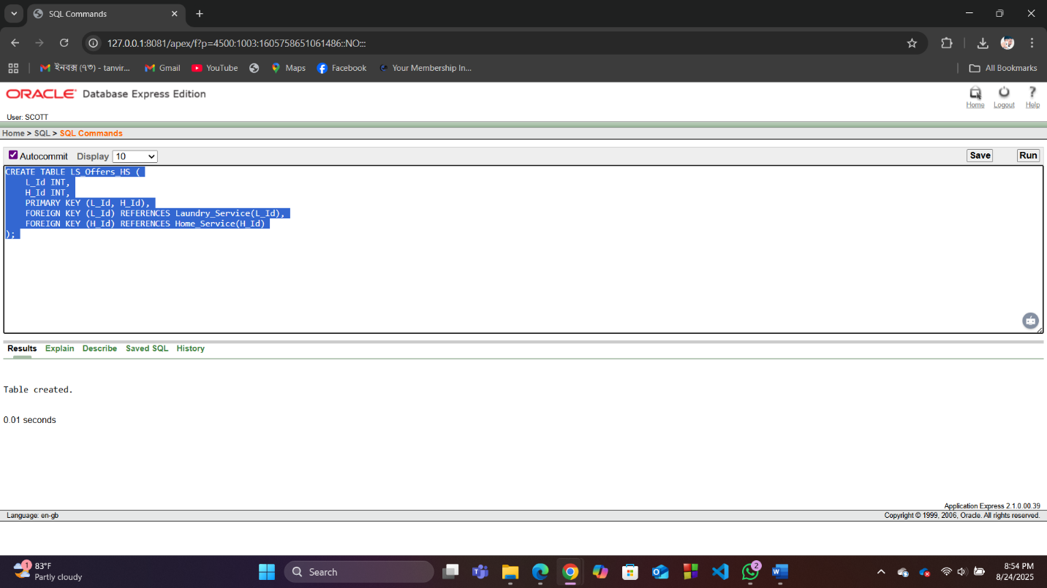

**For each created table inserted 5 rows of values:**

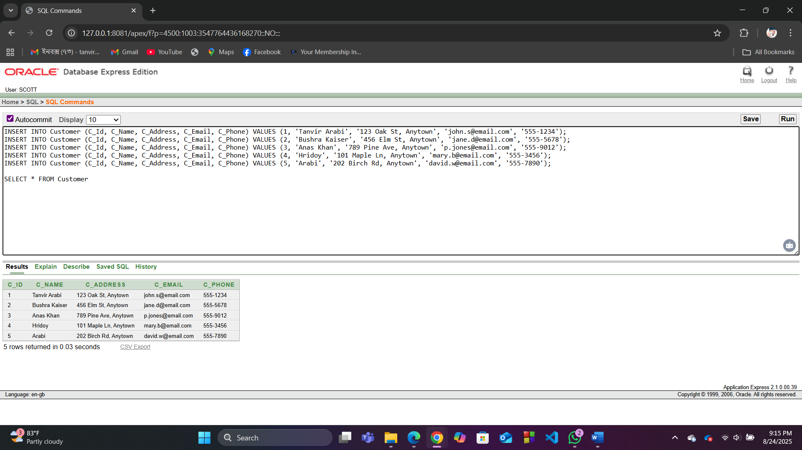

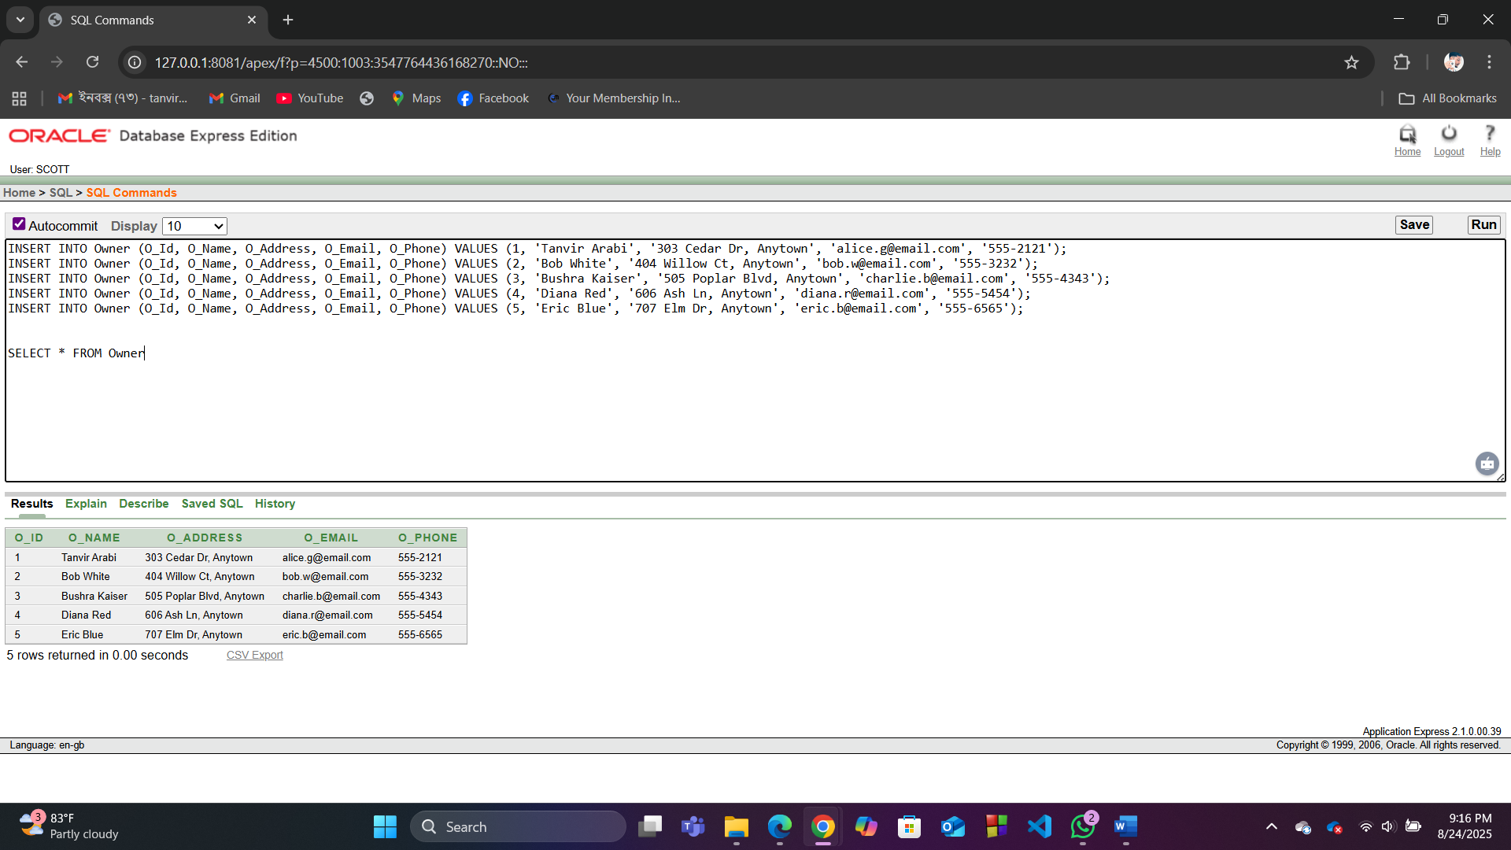

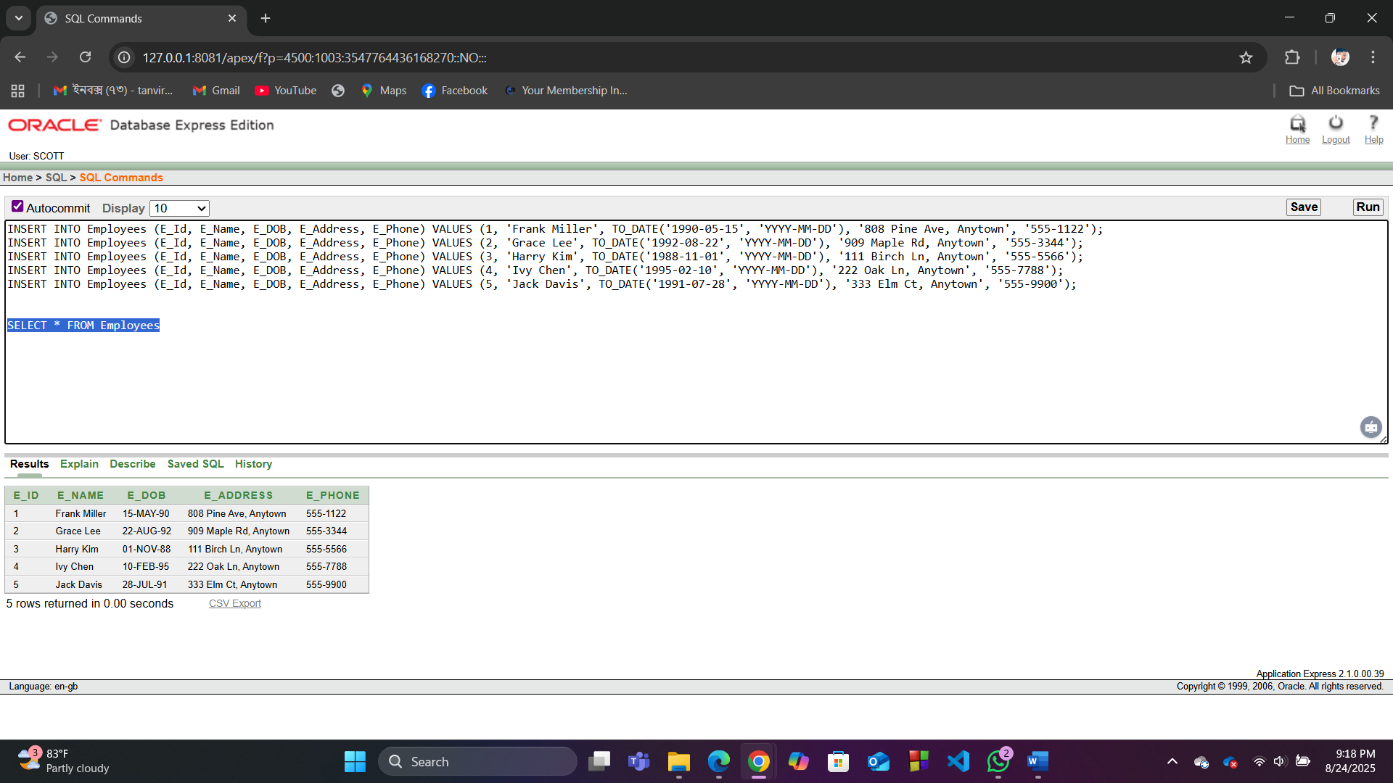

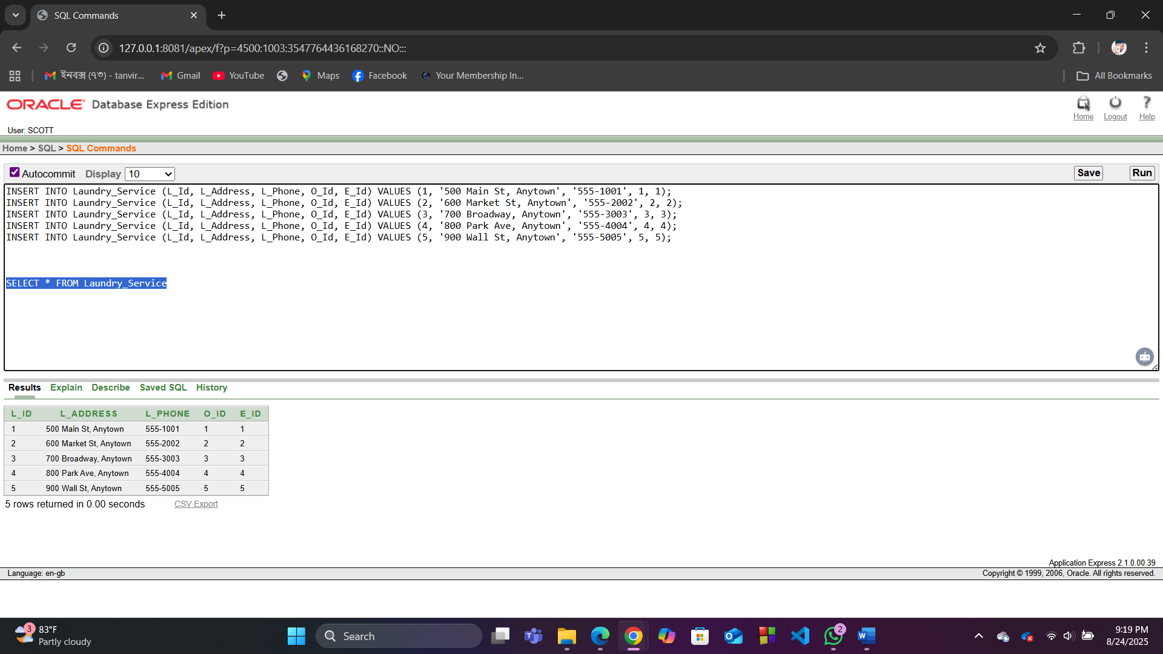

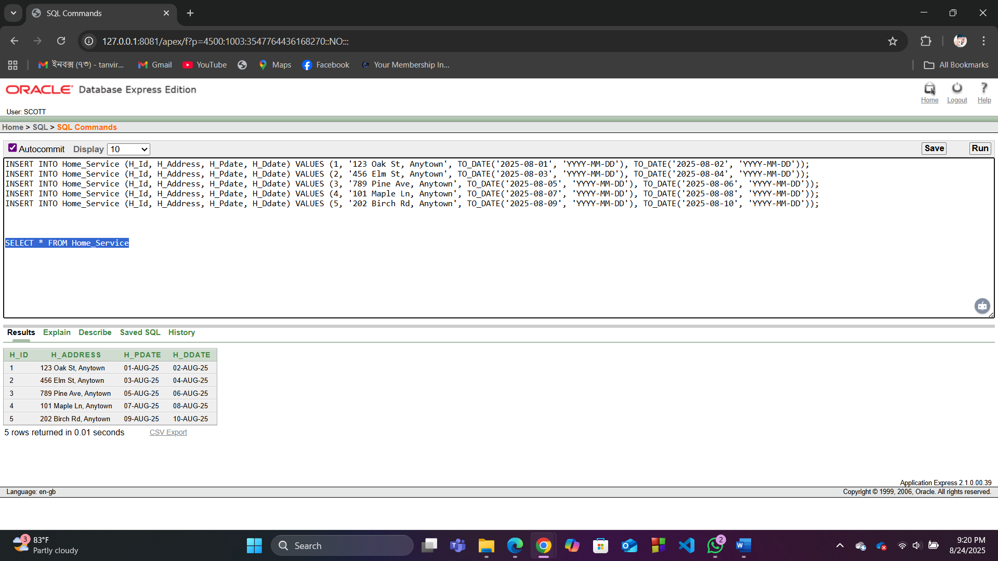

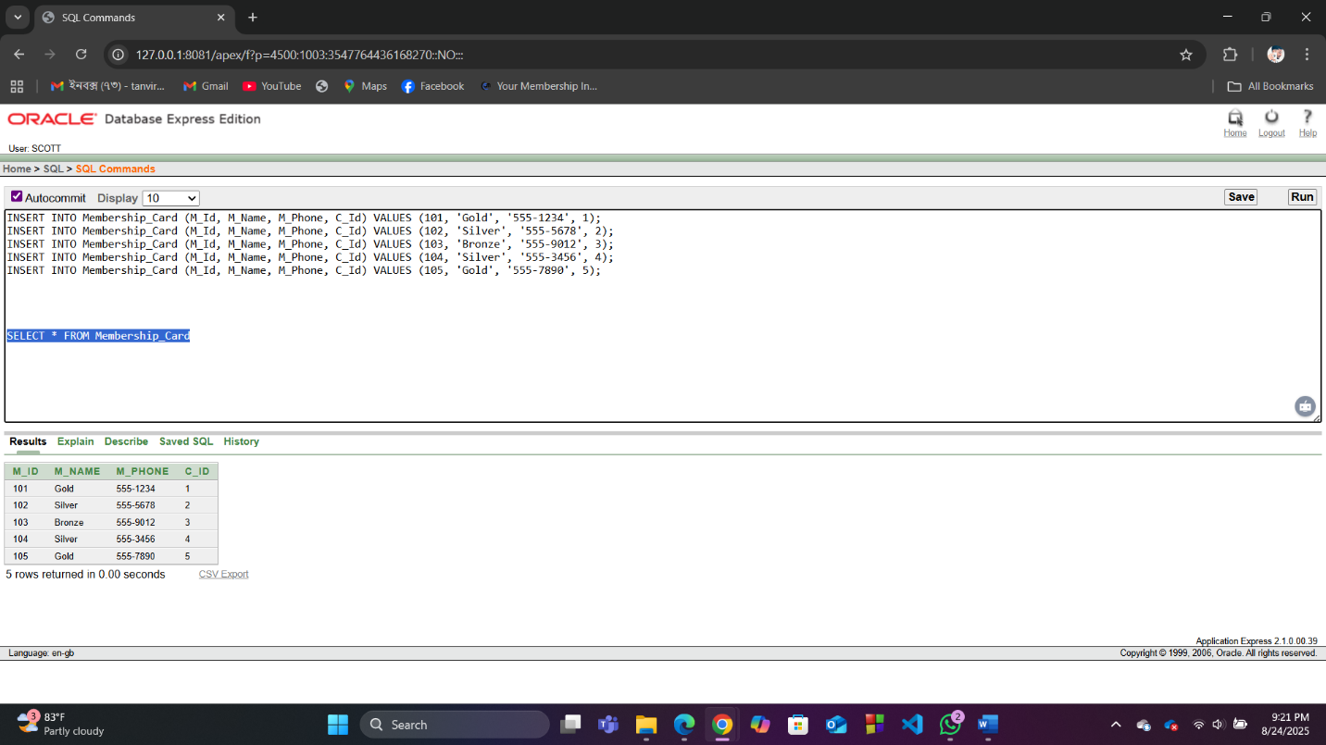

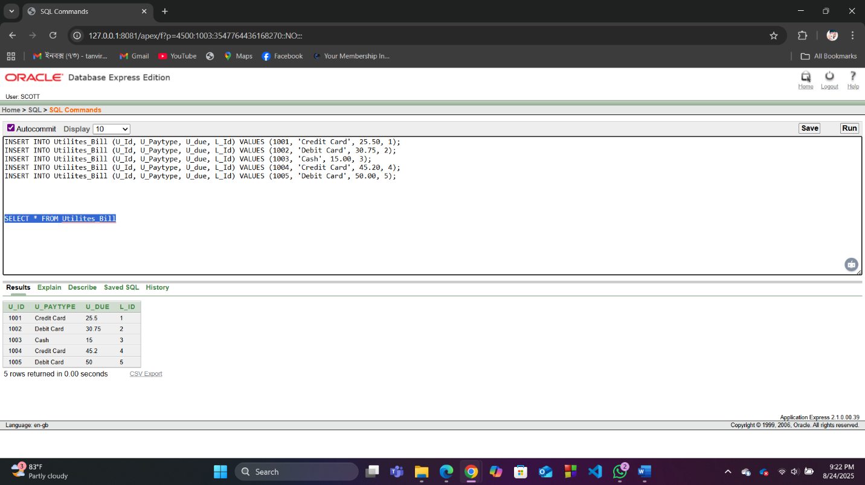

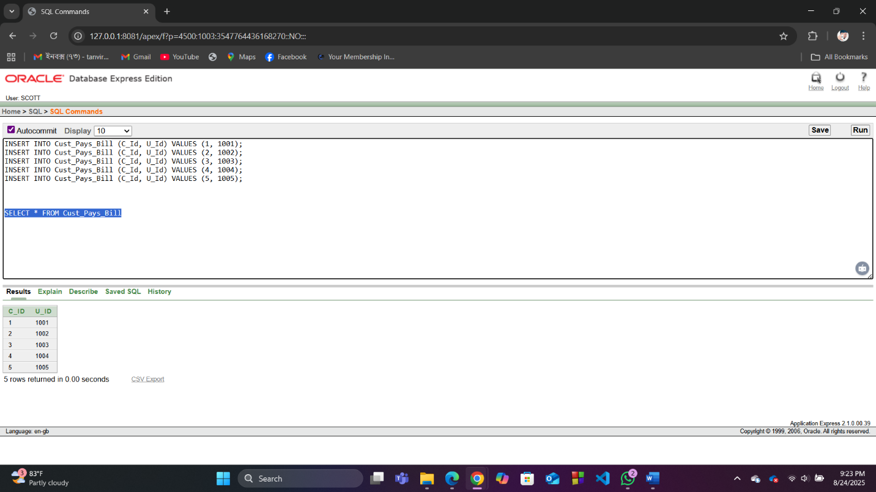

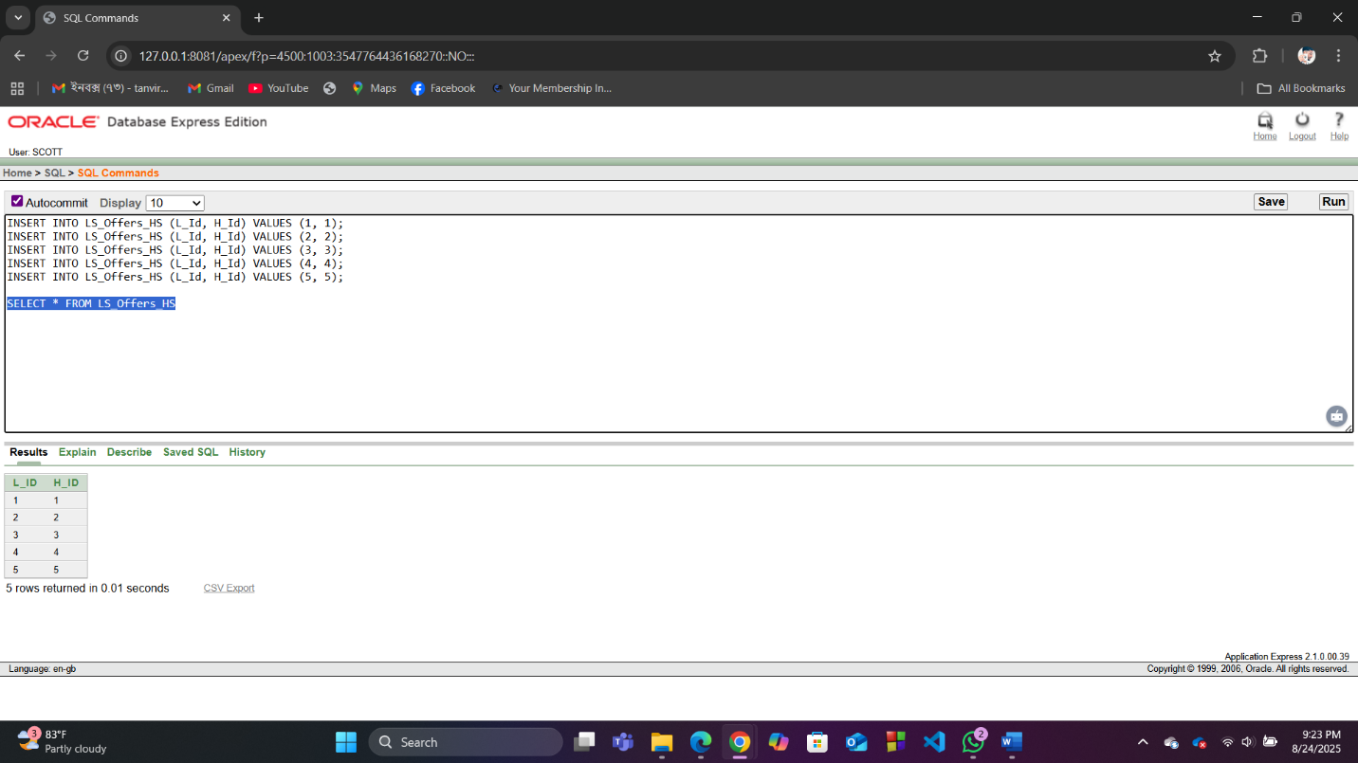

**Basic PL/SQL**

**1. Variables and Operators**

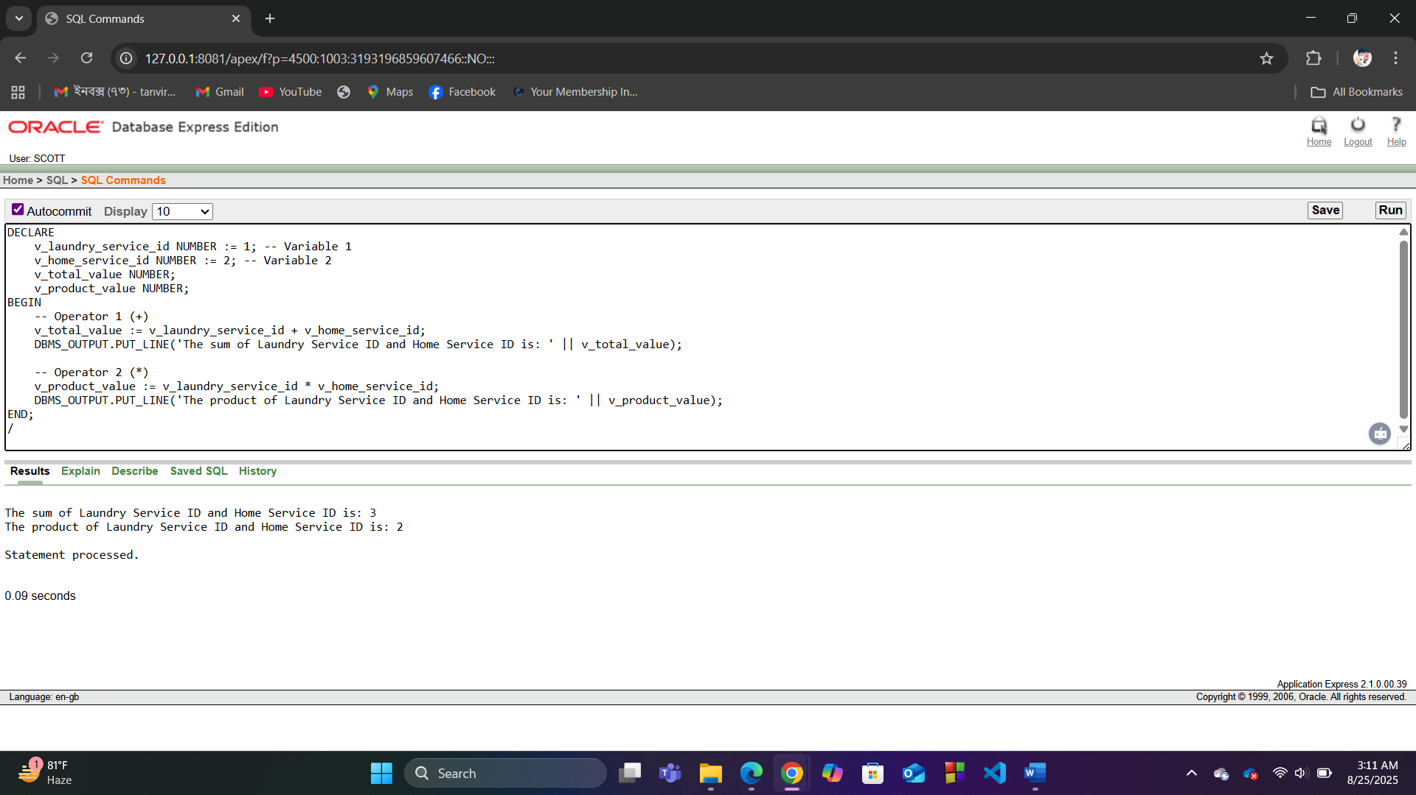

**2. Single-Row Functions**

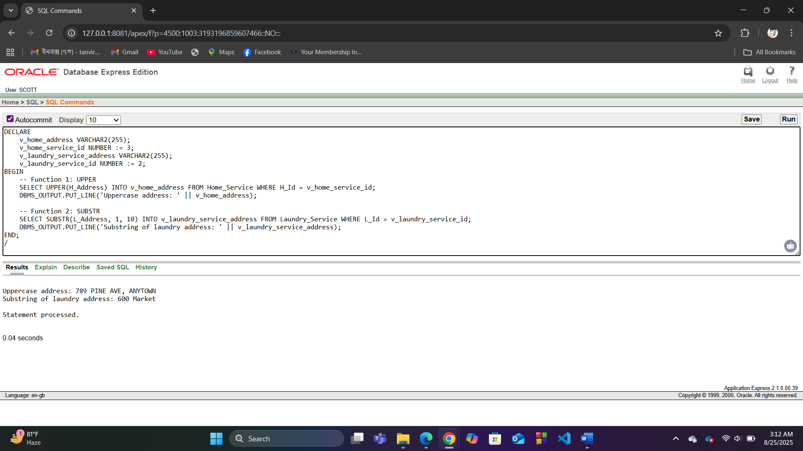

**3. Group Functions**

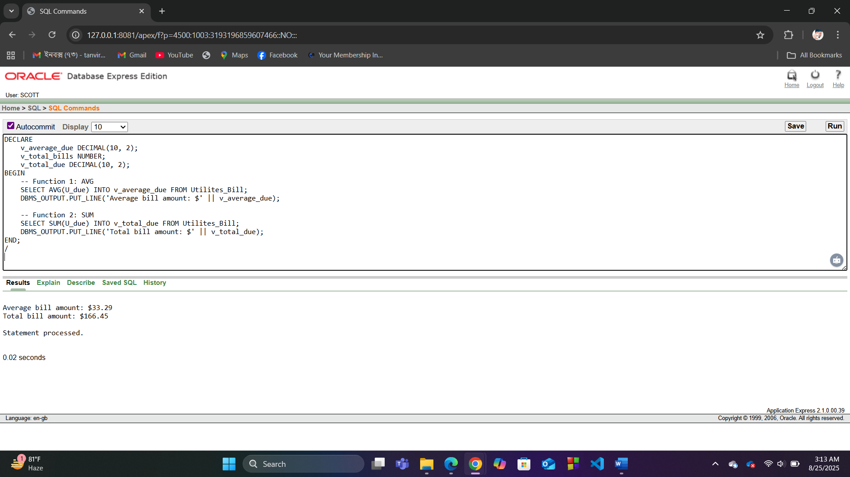

**4. Loop**

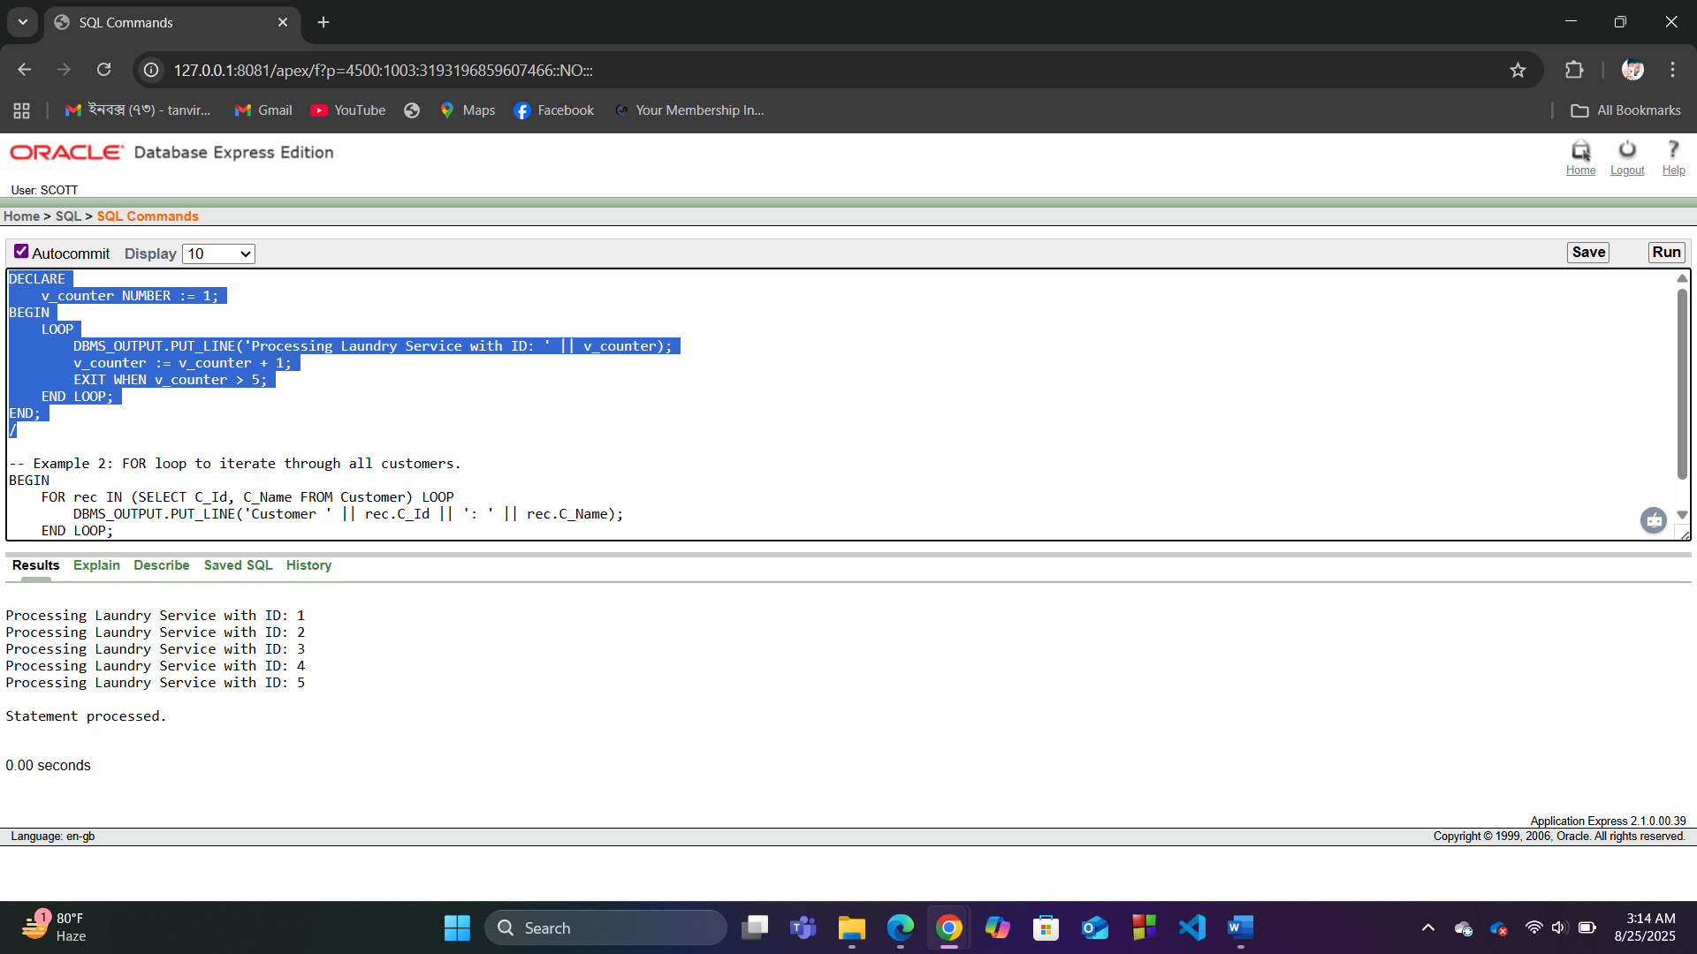

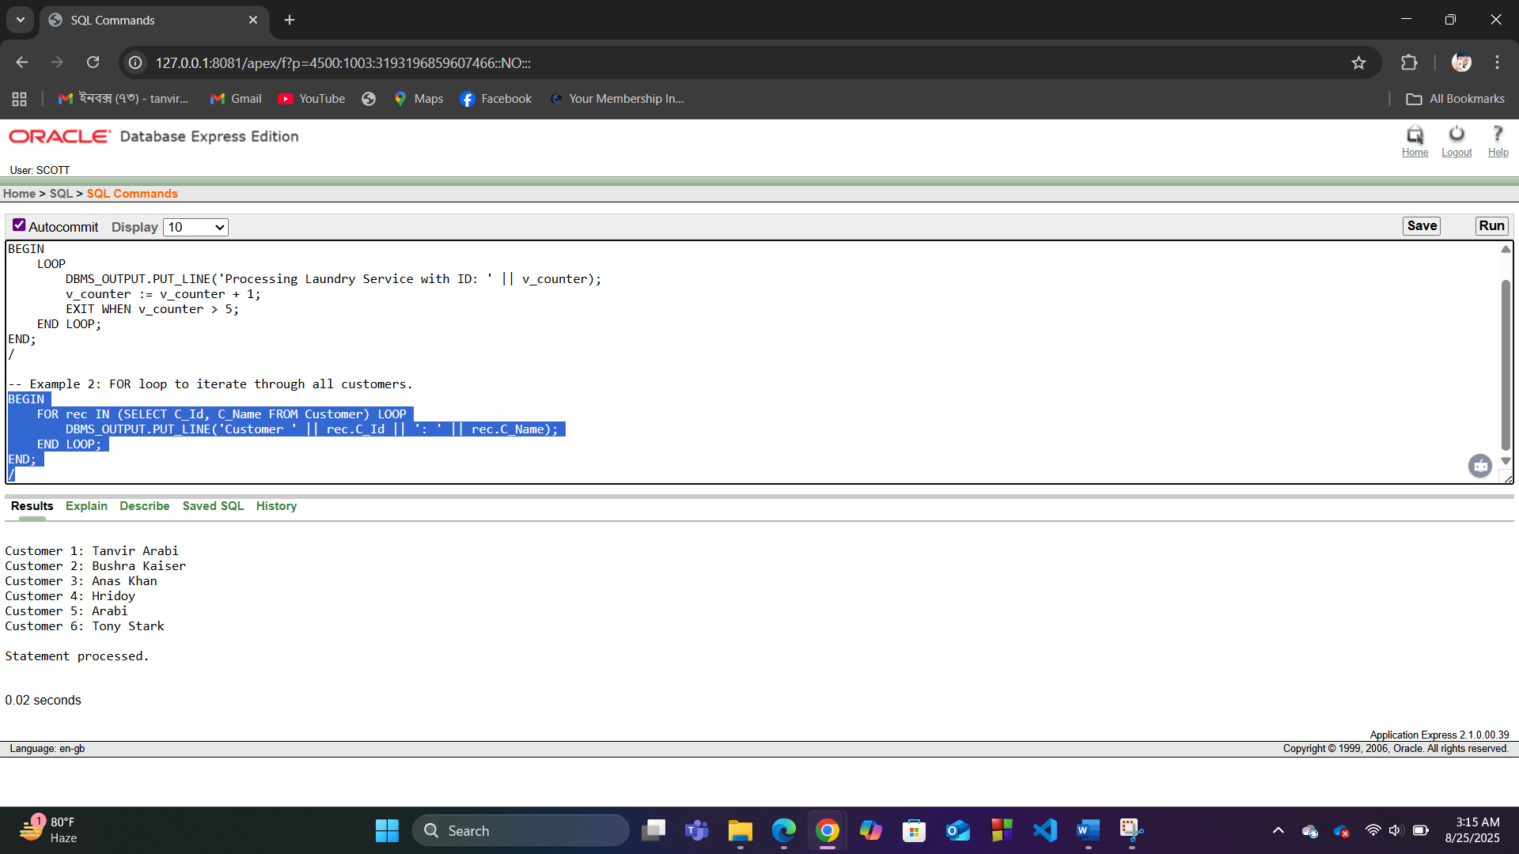

**5. Conditional Statements**

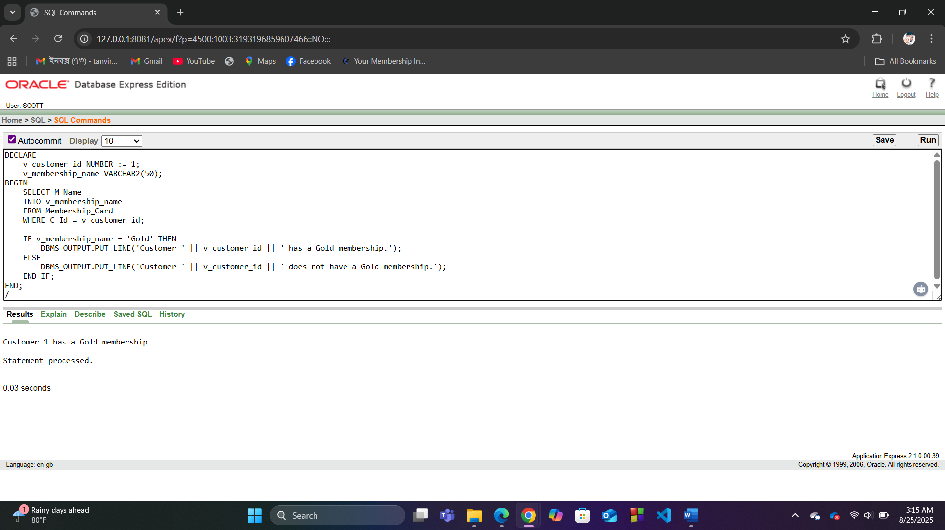

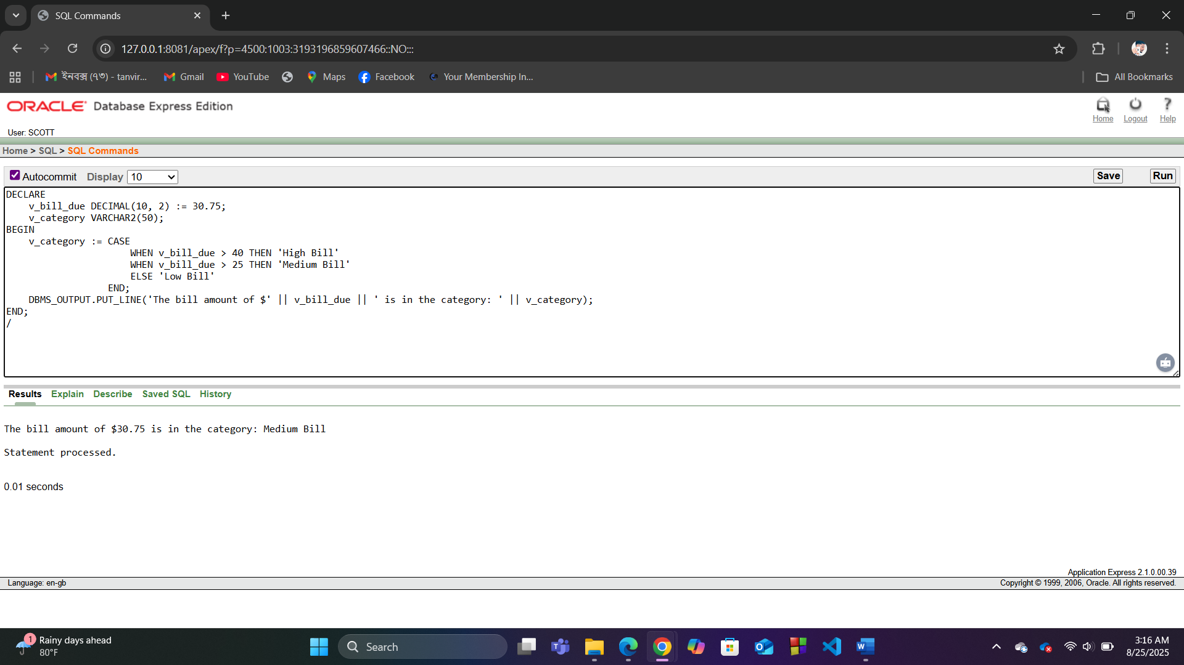

**6. Subquery**

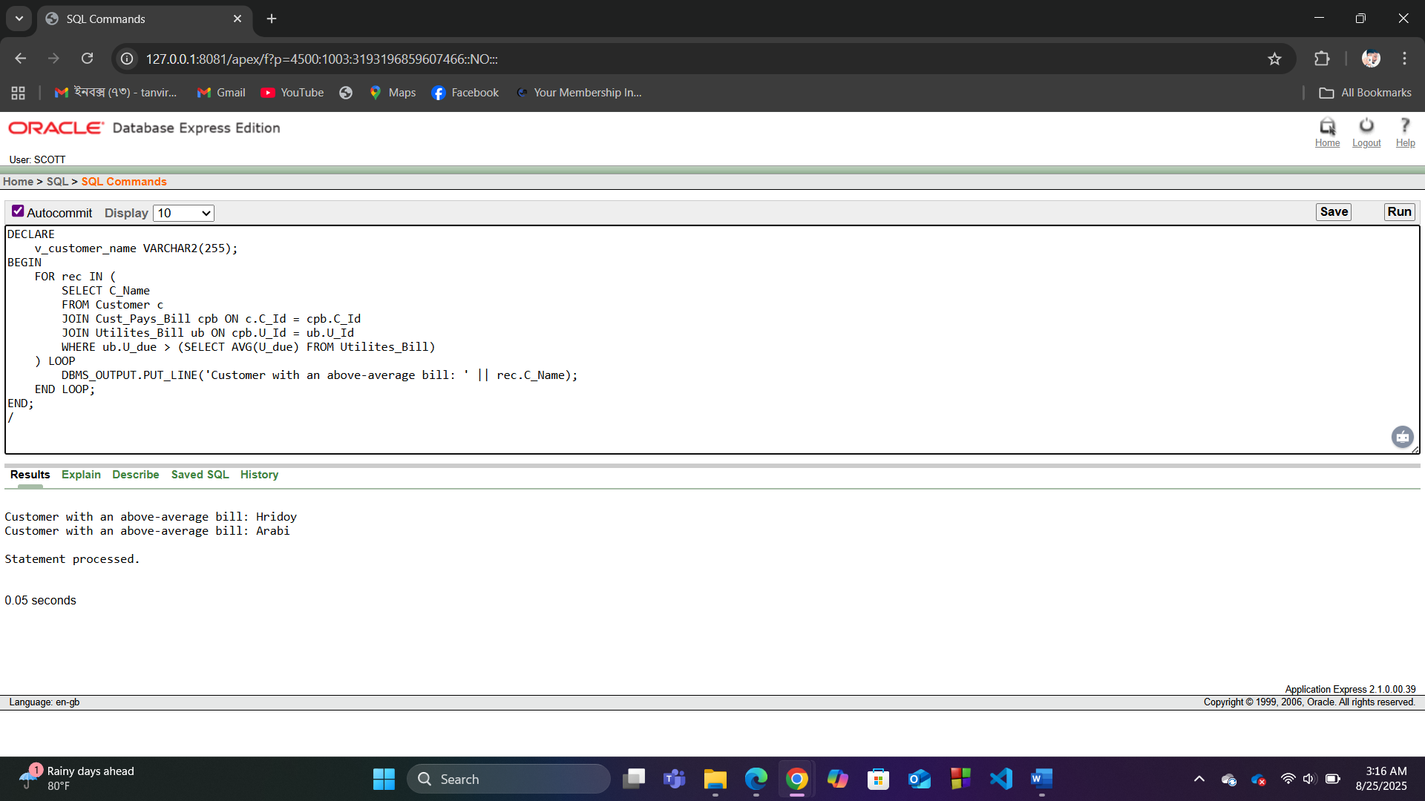

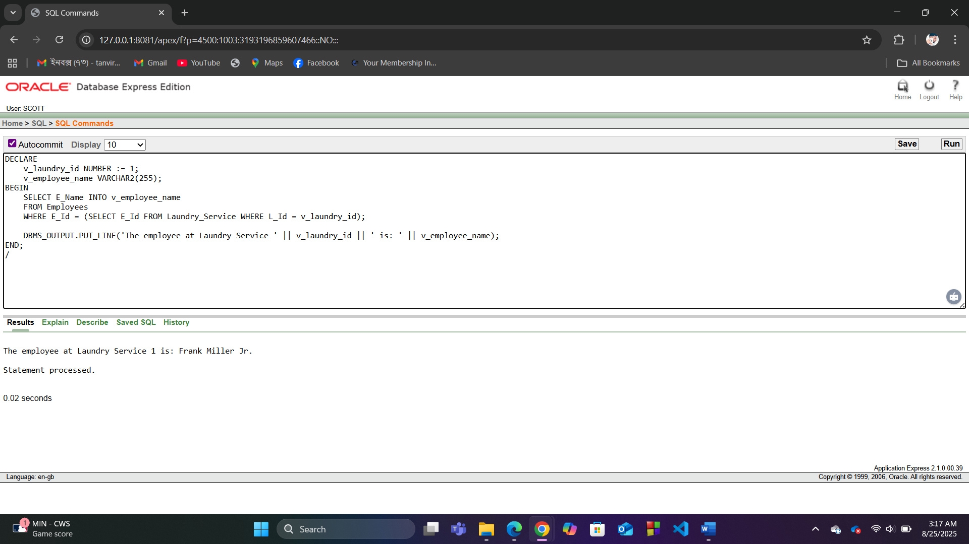

**7. Joining**

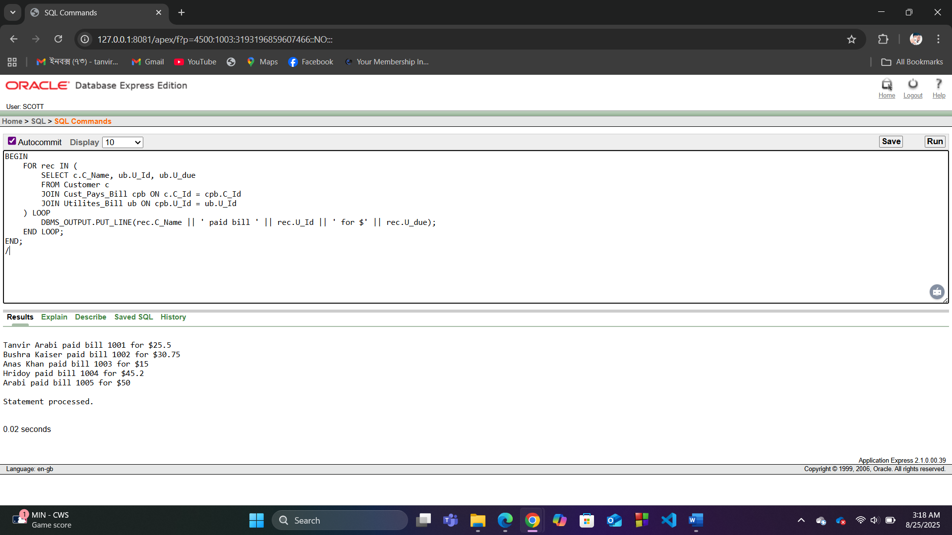

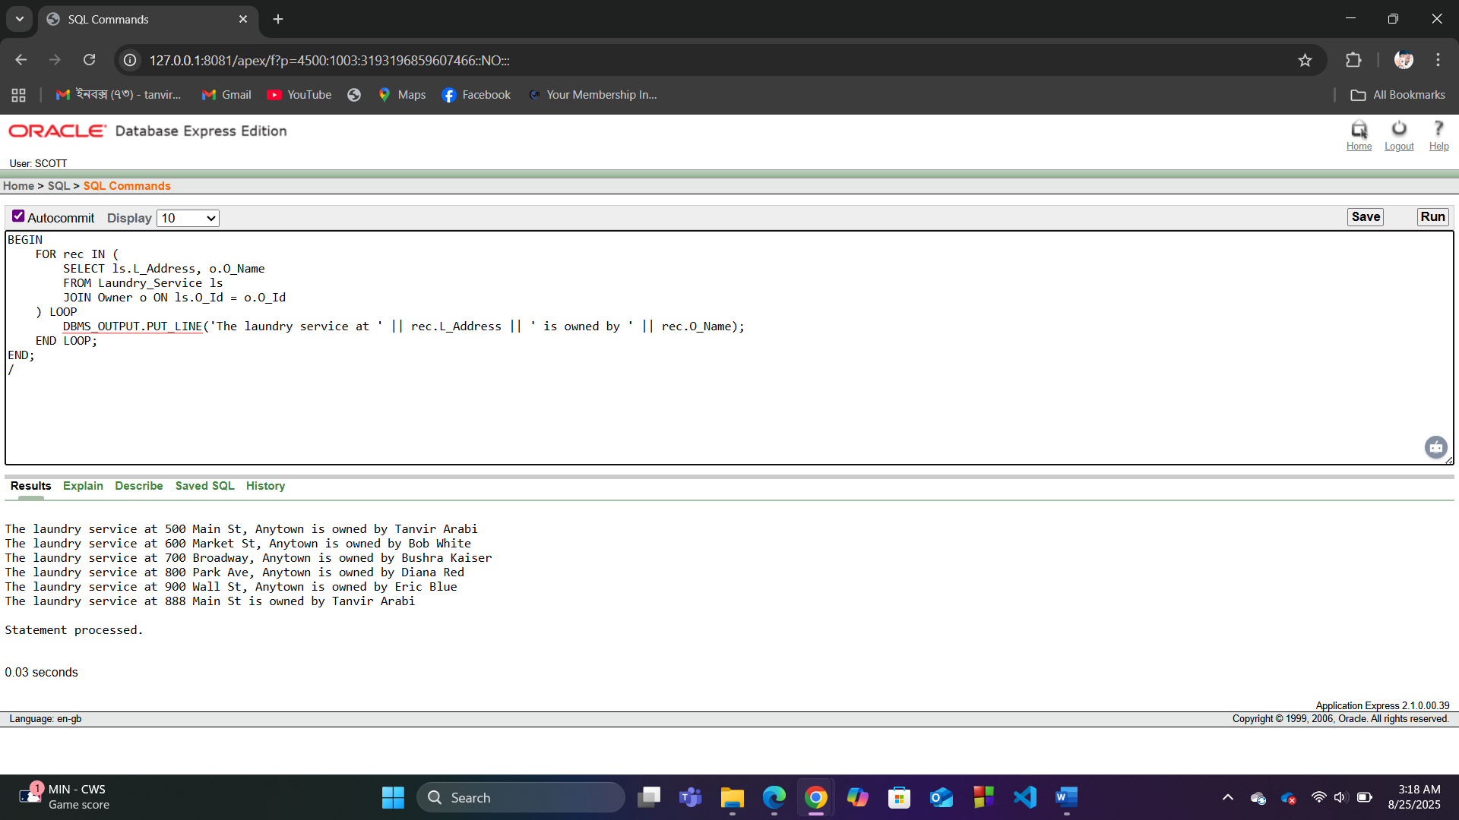

**ADVANCE PL/SQL**

**1. Stored Function**

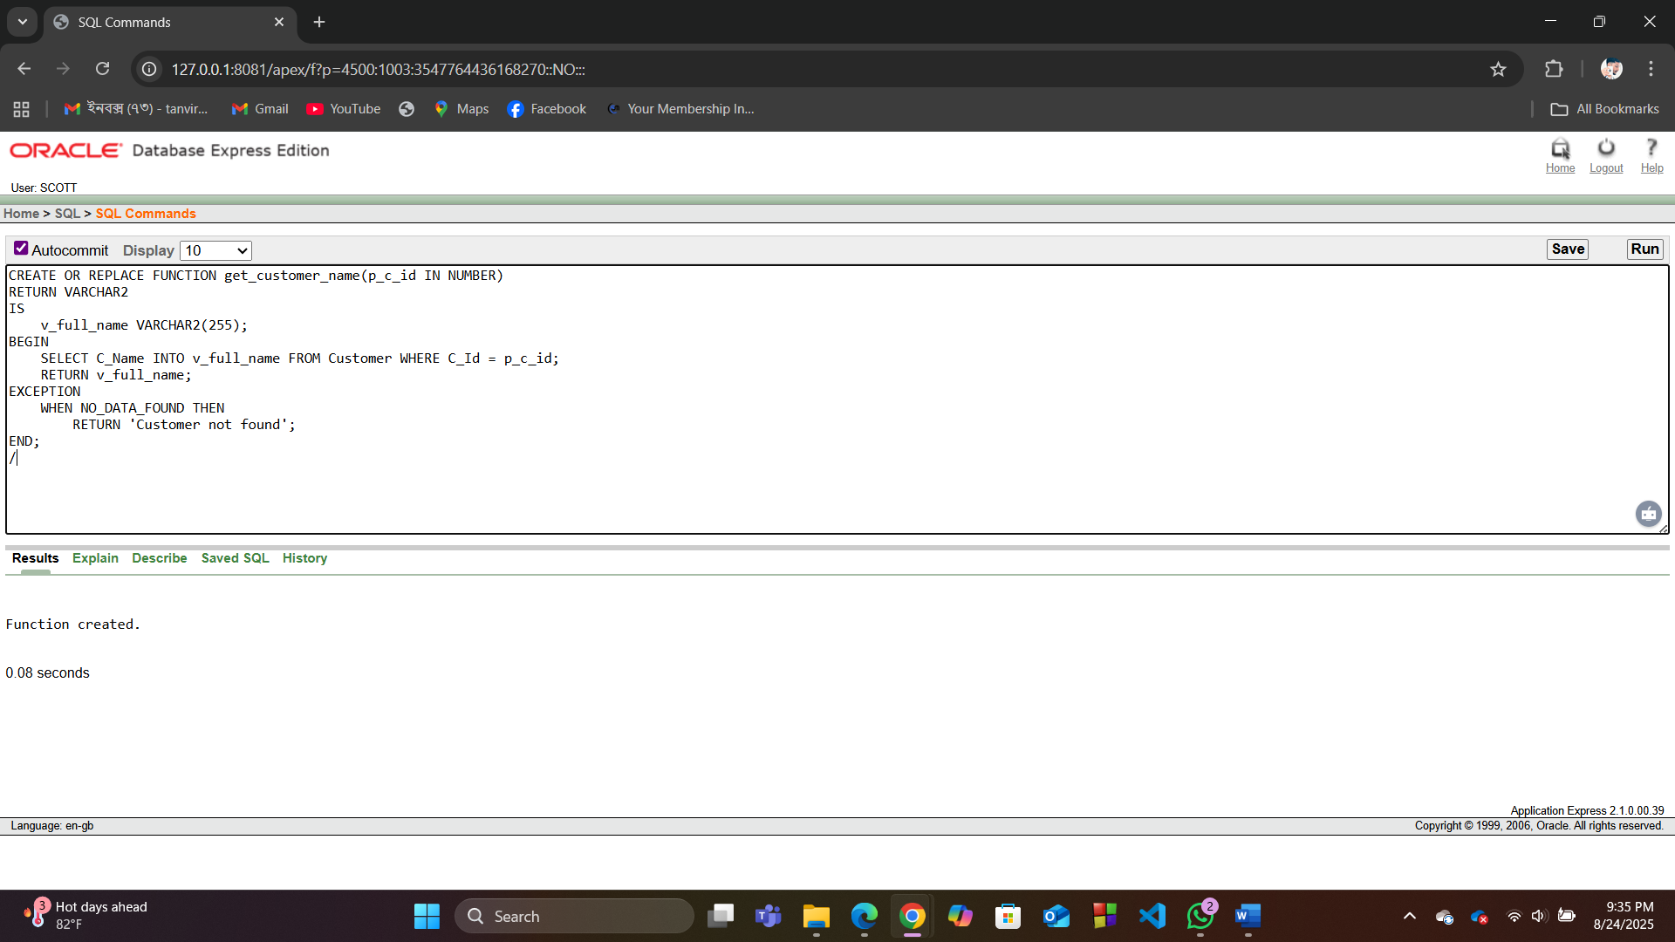

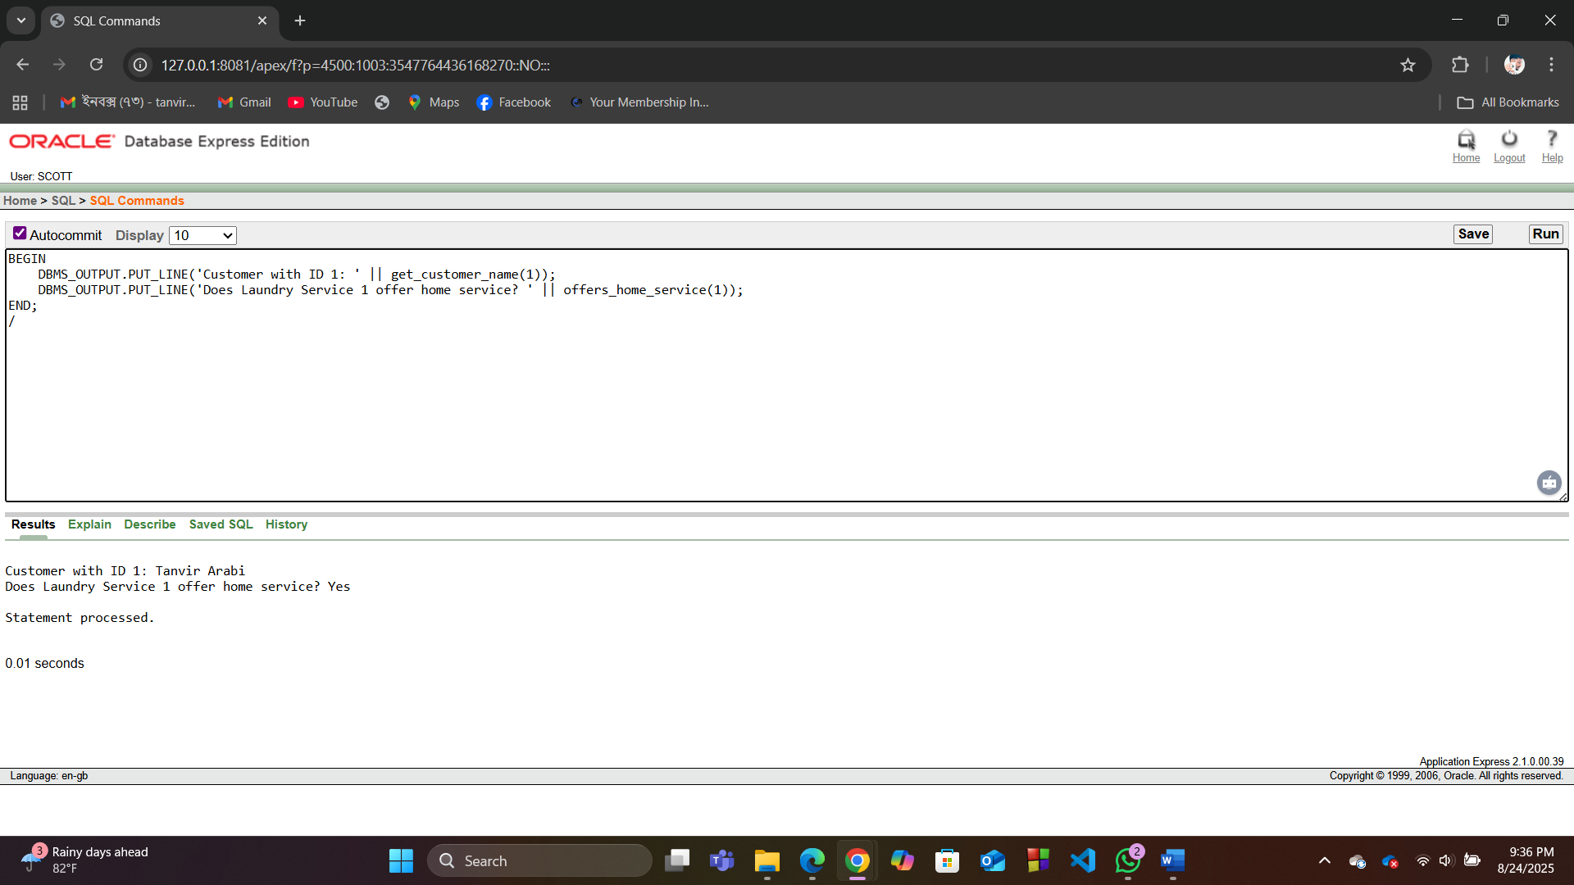

**2. Stored Procedure**

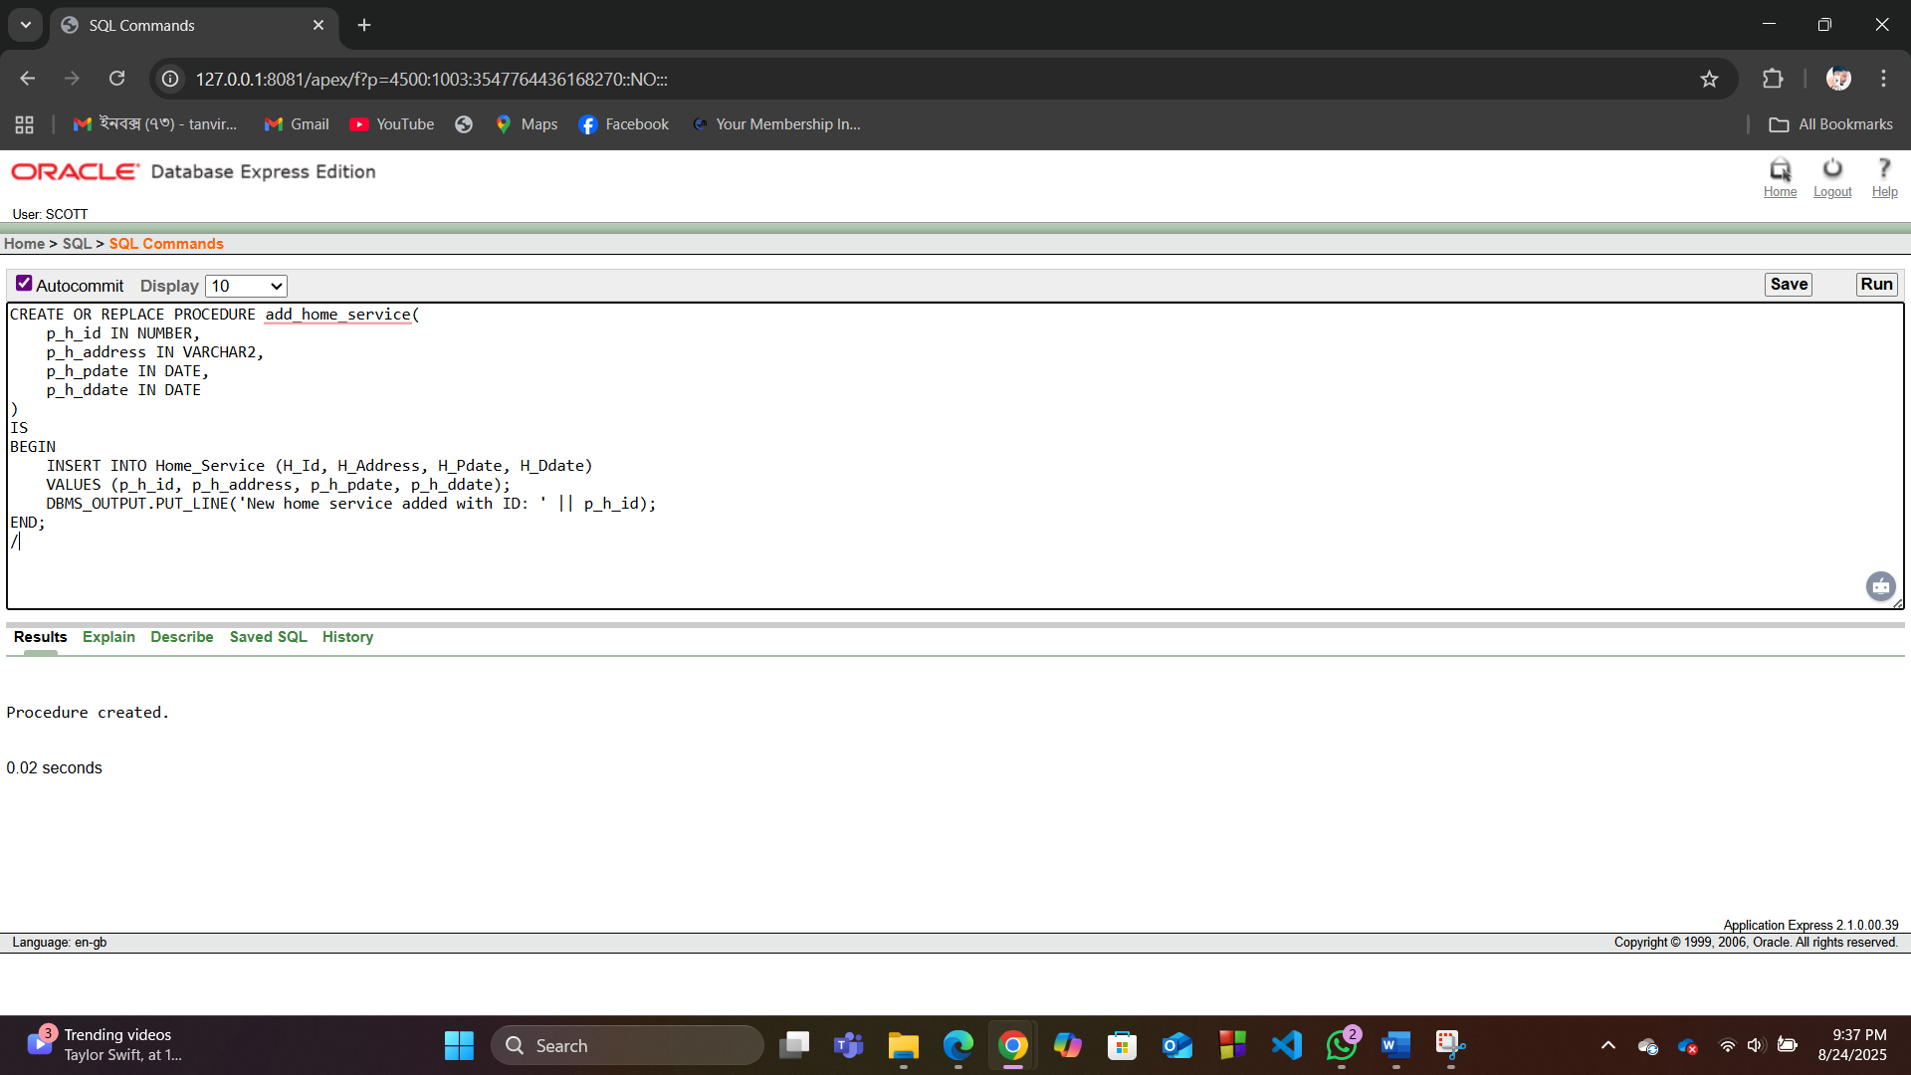

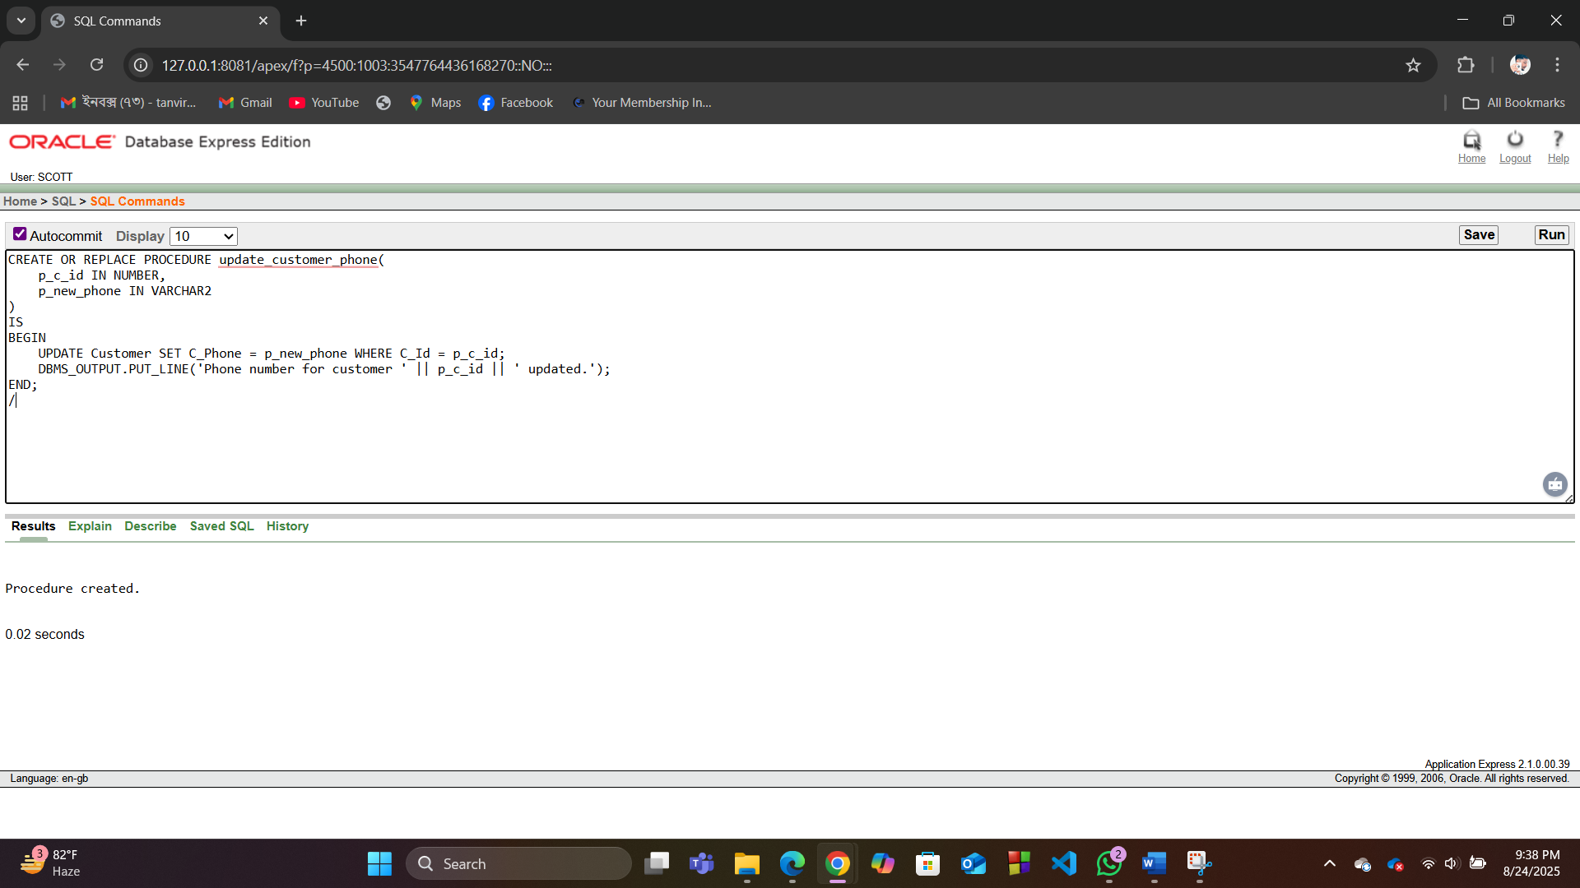

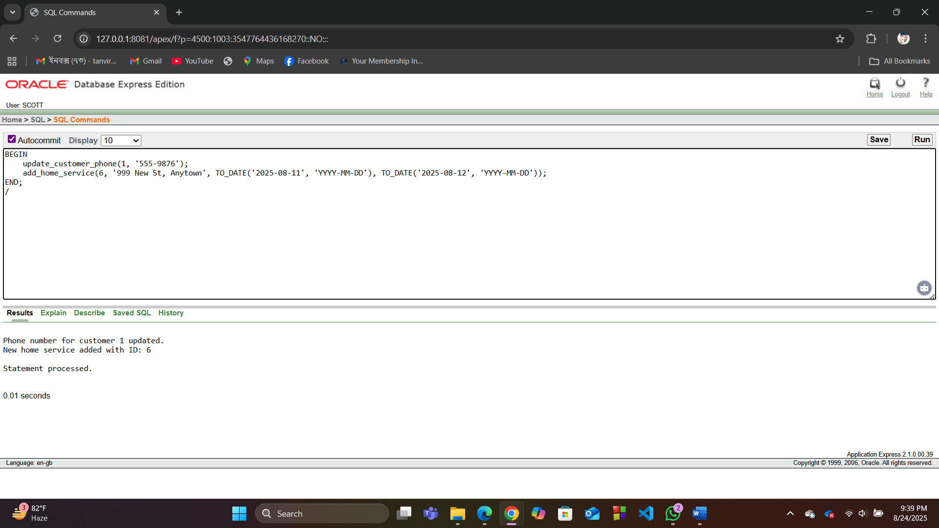

**3. Table-Based Record**

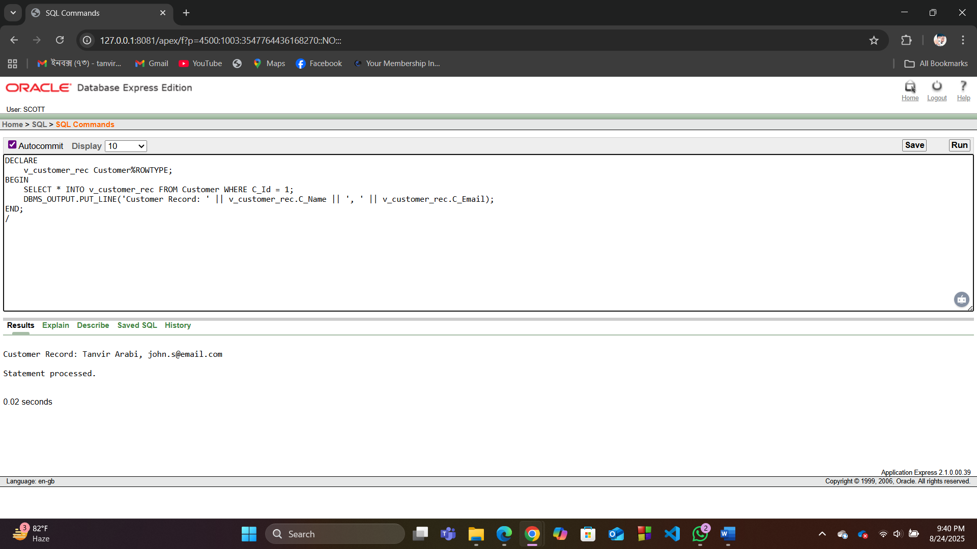

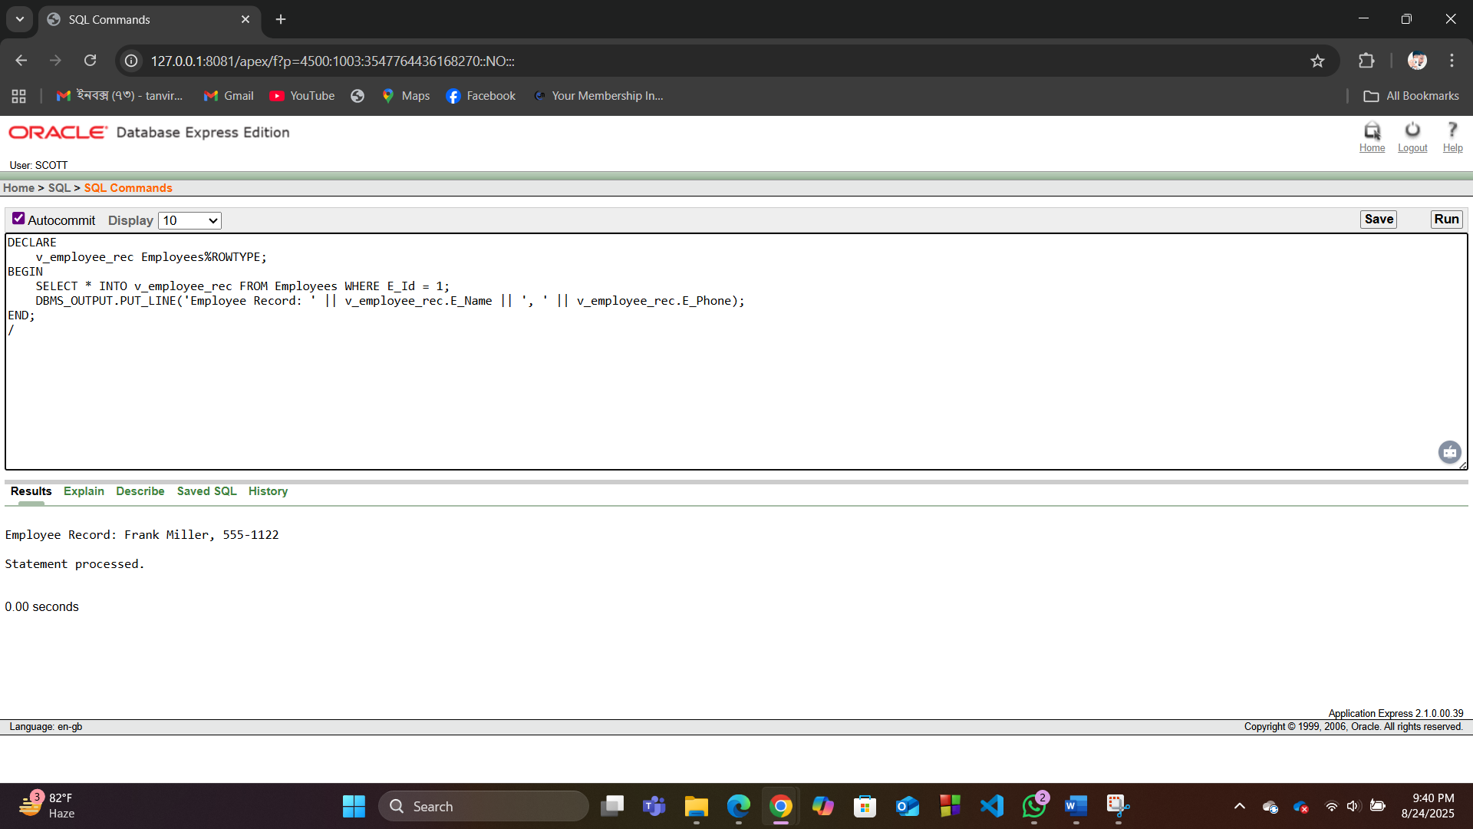

**4. Explicit Curso**

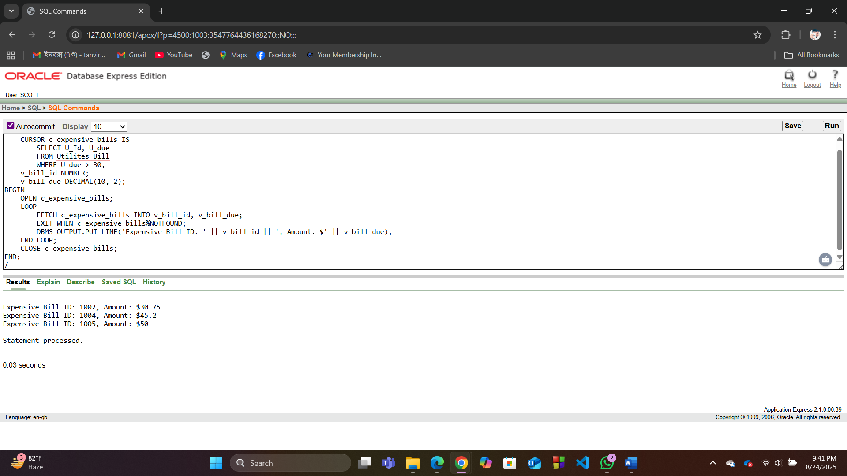

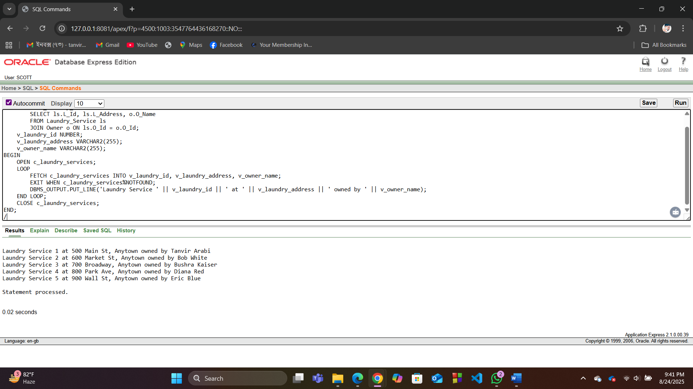

**5. Cursor-Based Record**

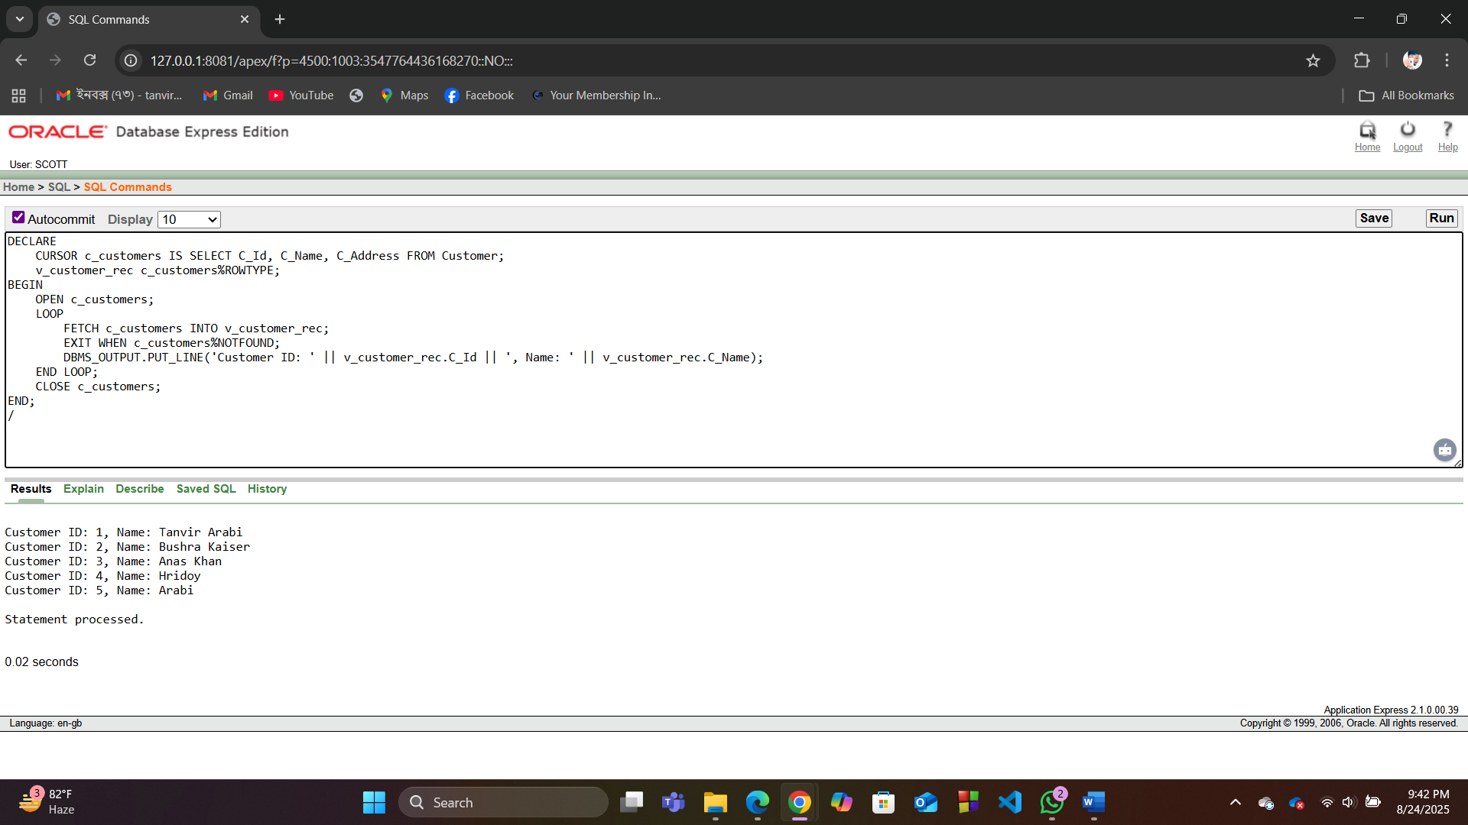

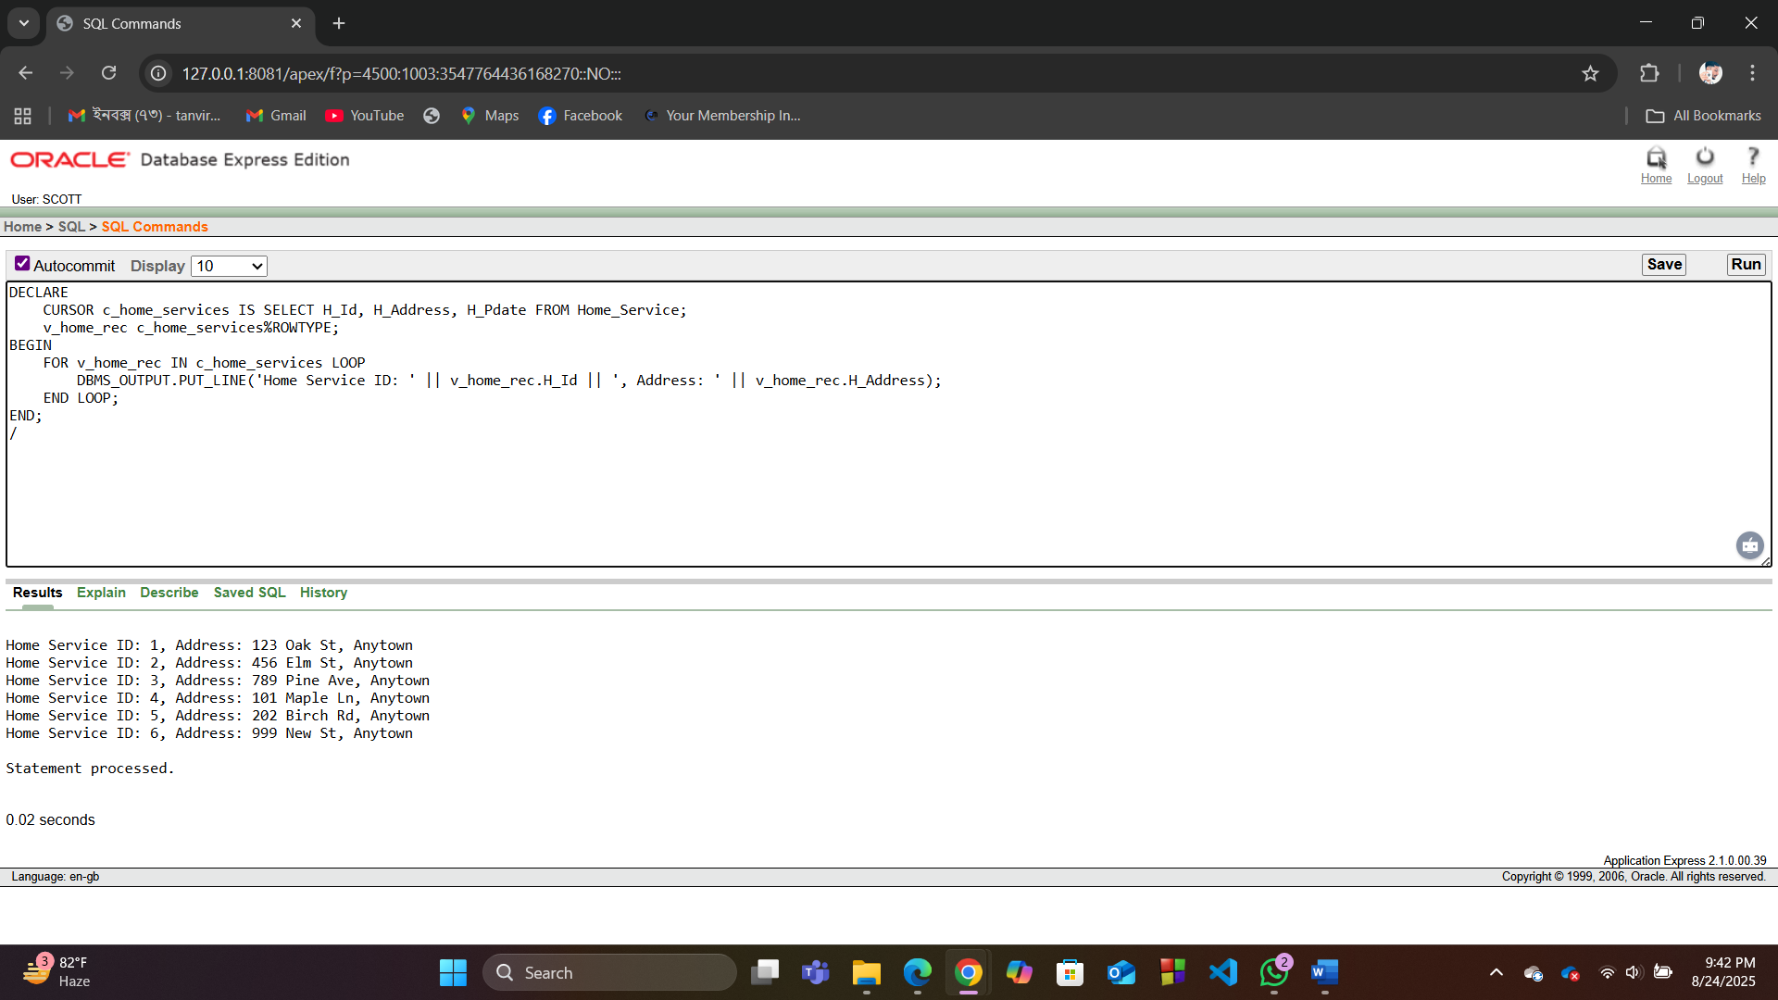

**6.. Row-Level Trigger (2 examples)**

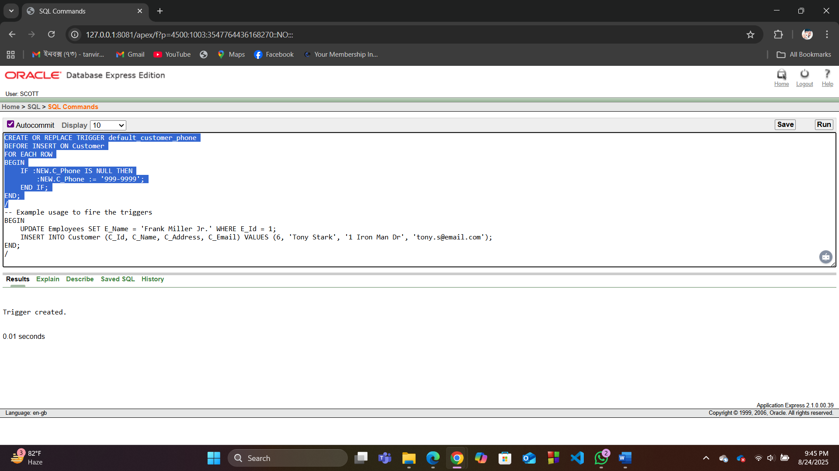

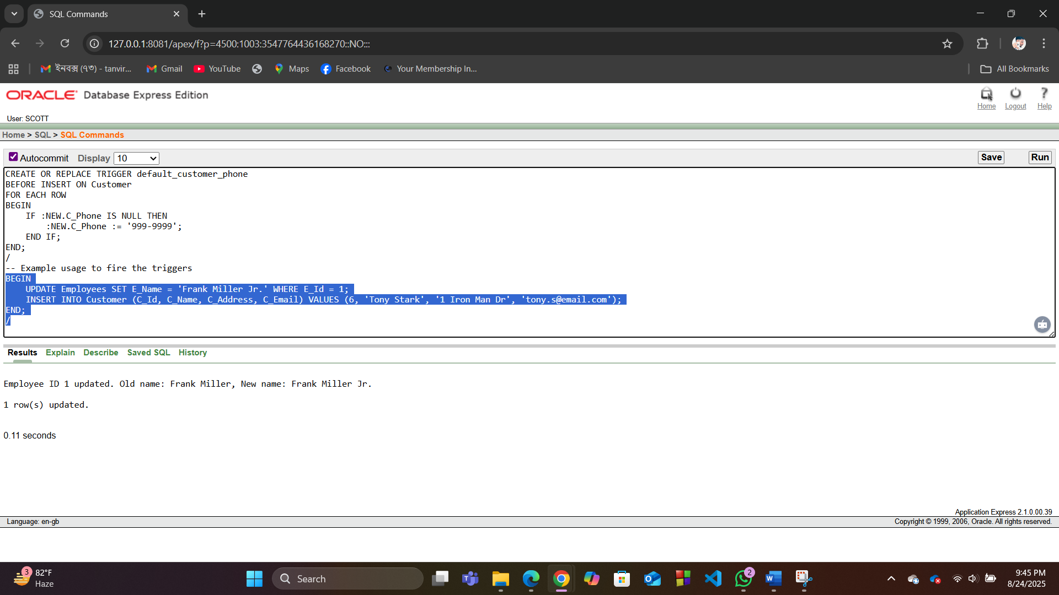

**7. Statement-Level Trigger**

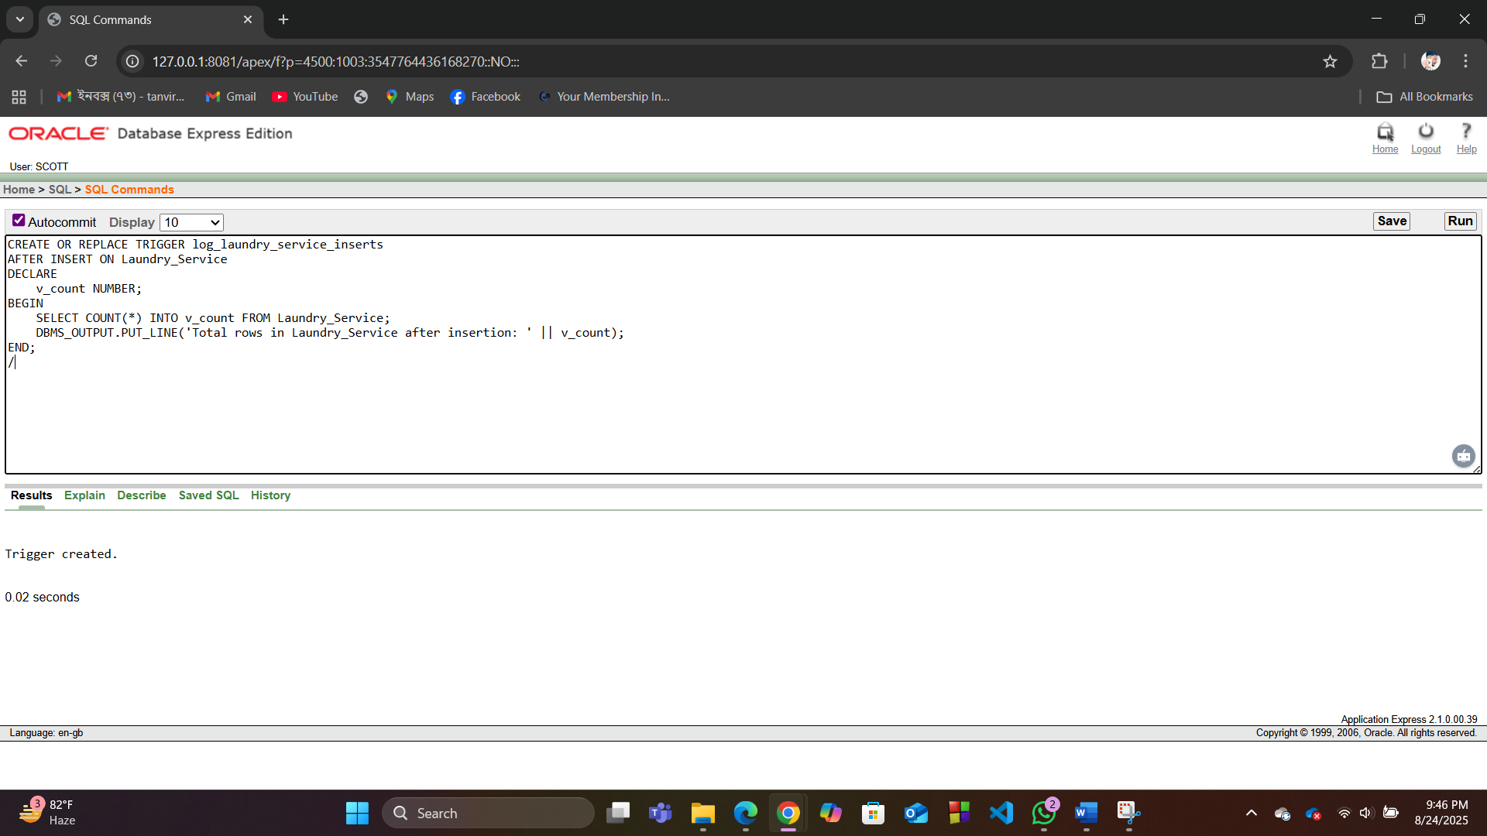

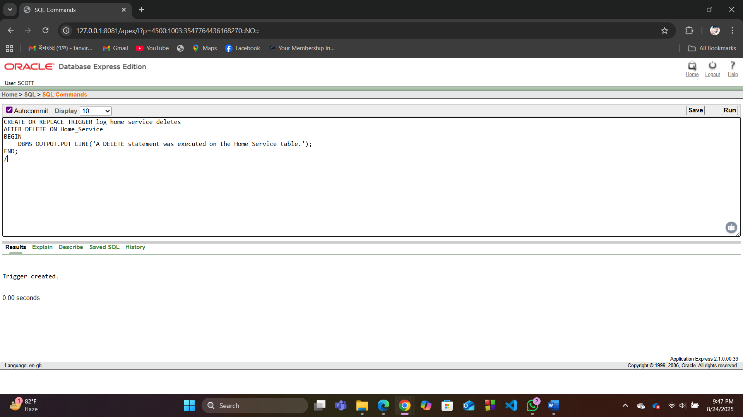

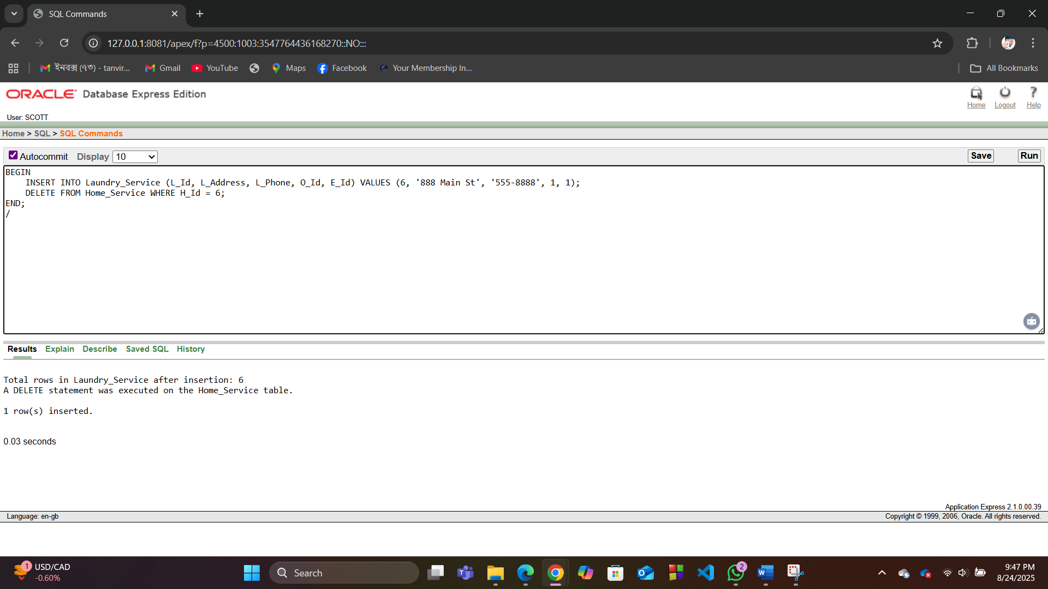

**8. Package**

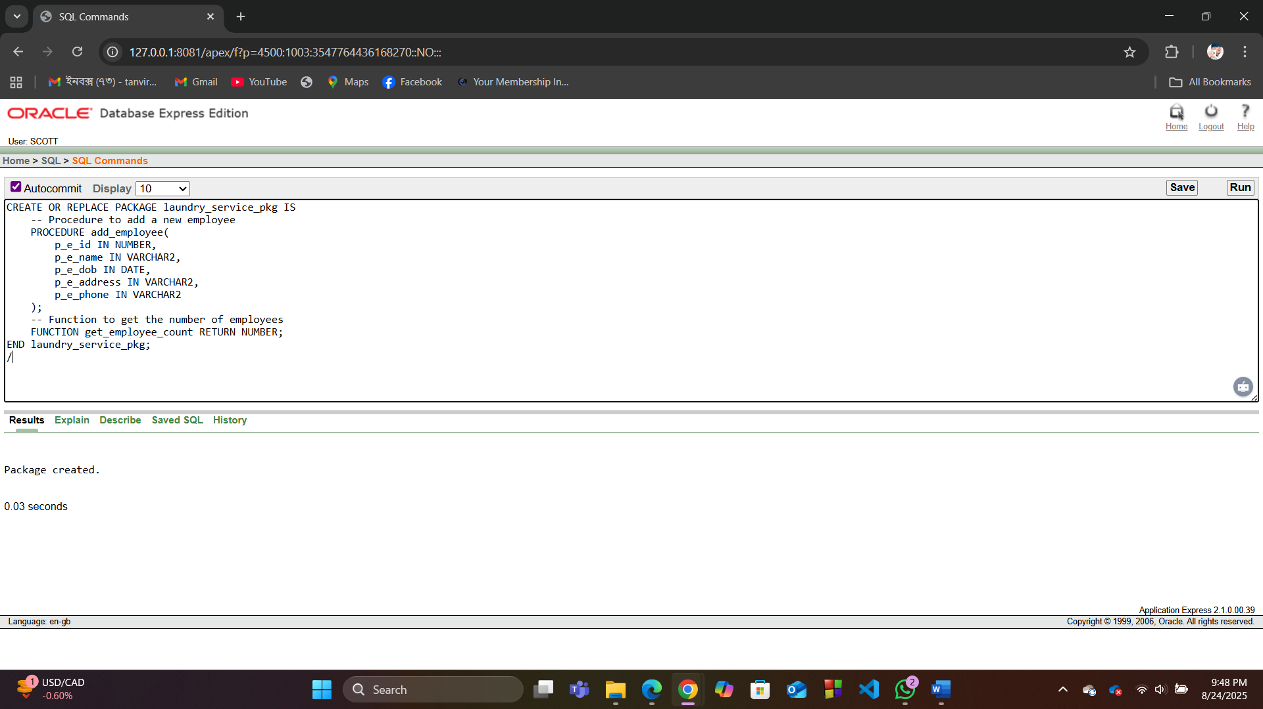

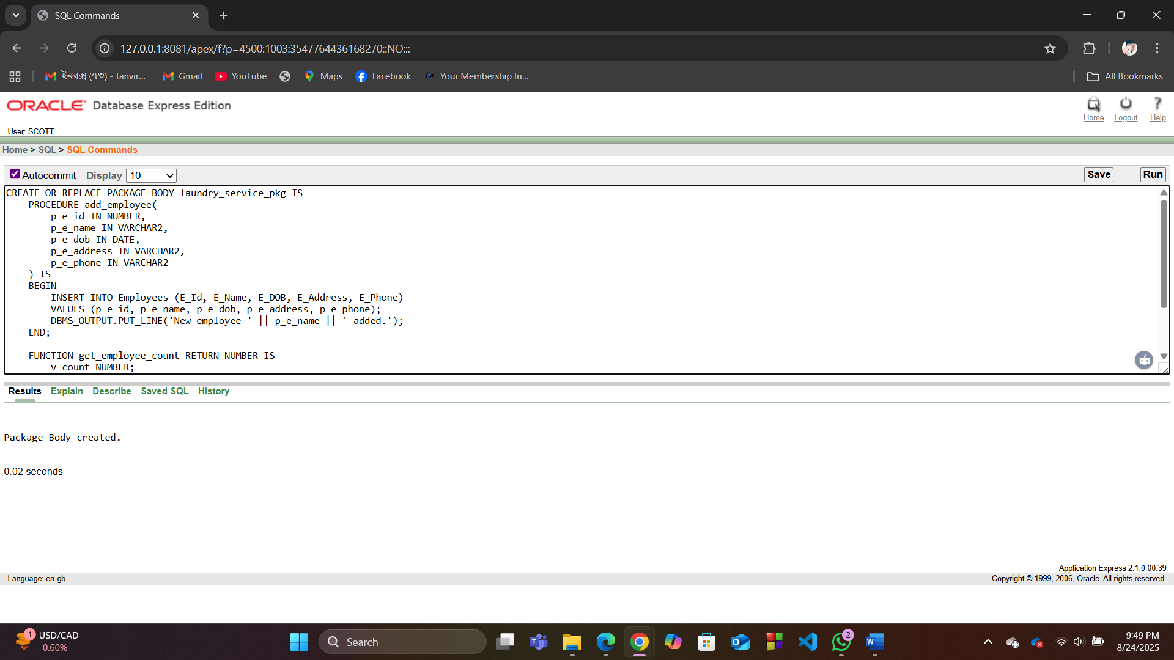

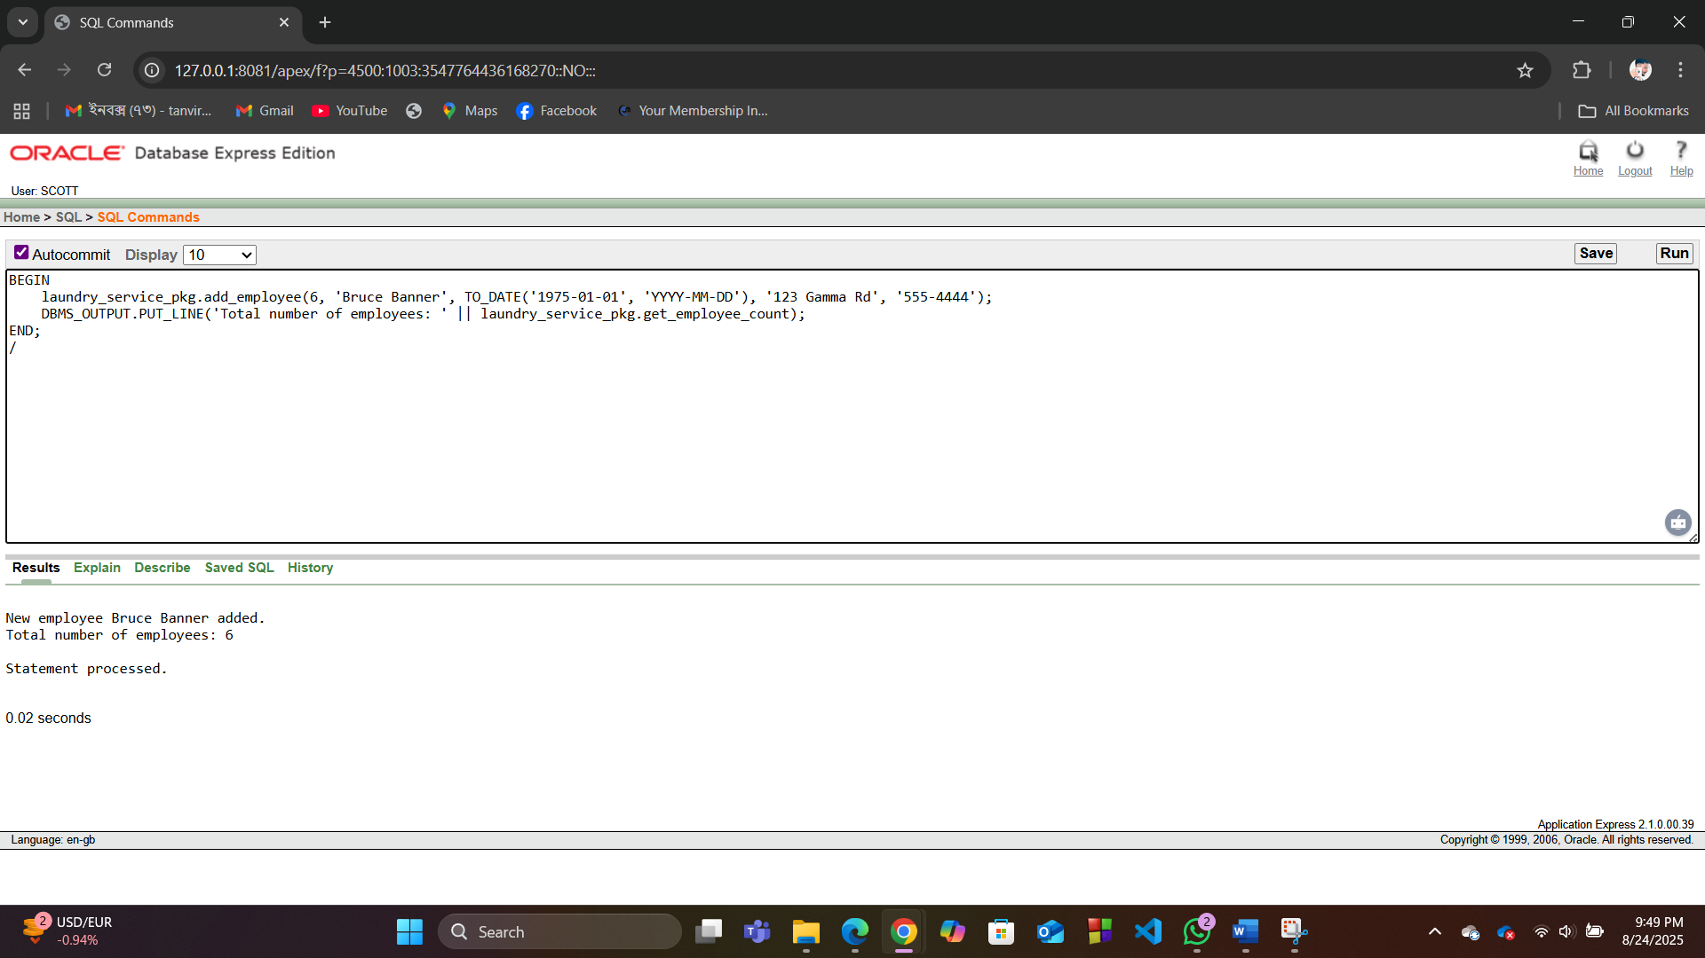

**Conclusion:**

 The Laundry Service Management System is currently an effective tool for boosting operational efficiency and customer satisfaction through automation and features like home service tracking. The proposed future work outlines a strategic evolution, beginning with integrating payment gateways and advanced analytics for immediate impact, followed by developing a mobile application to enhance accessibility and service delivery. The long-term vision involves incorporating AI for predictive maintenance and demand forecasting, along with sustainability tracking, to transform the system into an innovative, data-driven platform that ensures scalable growth and a significant competitive advantage in the market.